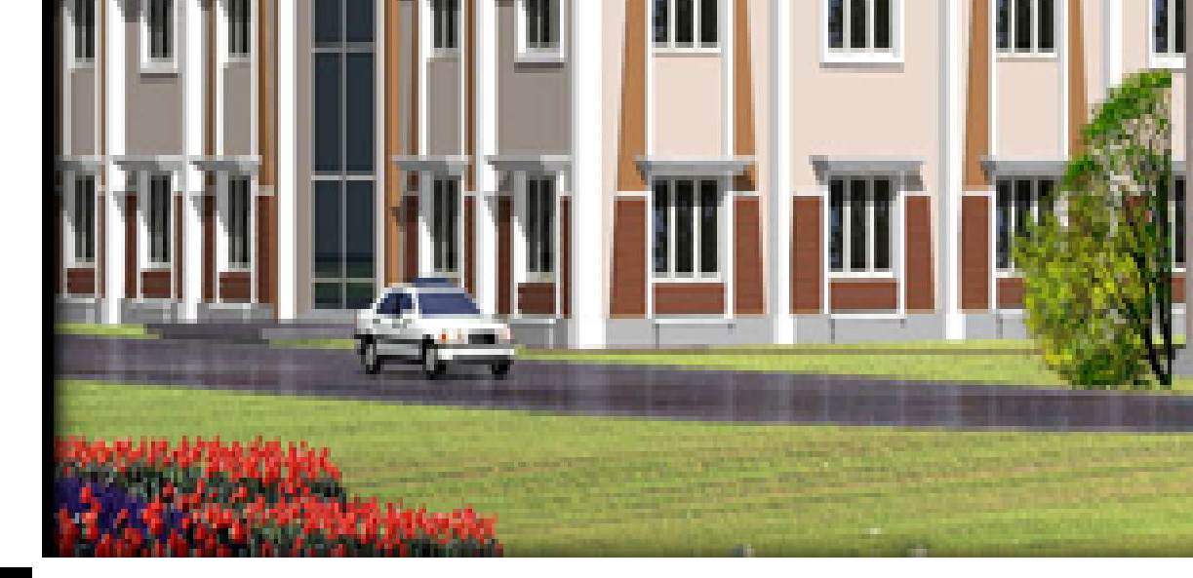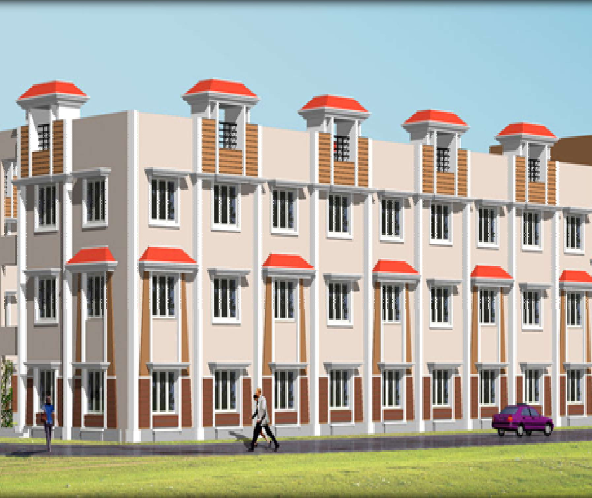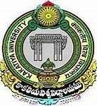
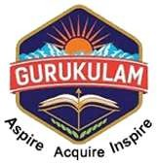
TELANGANATRIBALWELFARE RESIDENTIALDEGREECOLLEGE(GIRLS)KHAMMAM
(AffiliatedtoKakatiyaUniversity)
COLLEGECODE:645
Email:ttwrdcgirls.khammam@gmail.comPh.no:9491063083

DEPARTMENT OFCOMPUTERSCIENCEANDAPPLICATIONS

https://www.ttwrdcs.ac.in/Khammam/

*****

Department Activities 2018-19

*****
w

DEPARTMENTOF
COMPUTERSCIENCEANDAPPLICATIONS
https://ww.ttwrdcs.ac.in/Khammam/

POSTER PRESENTATION

TOPIC : Computer Scientists and Hardware parts
DATE : 18-09-2018
PARTICIPANTS : I-BS.C-MPCS&B.COM(CA)

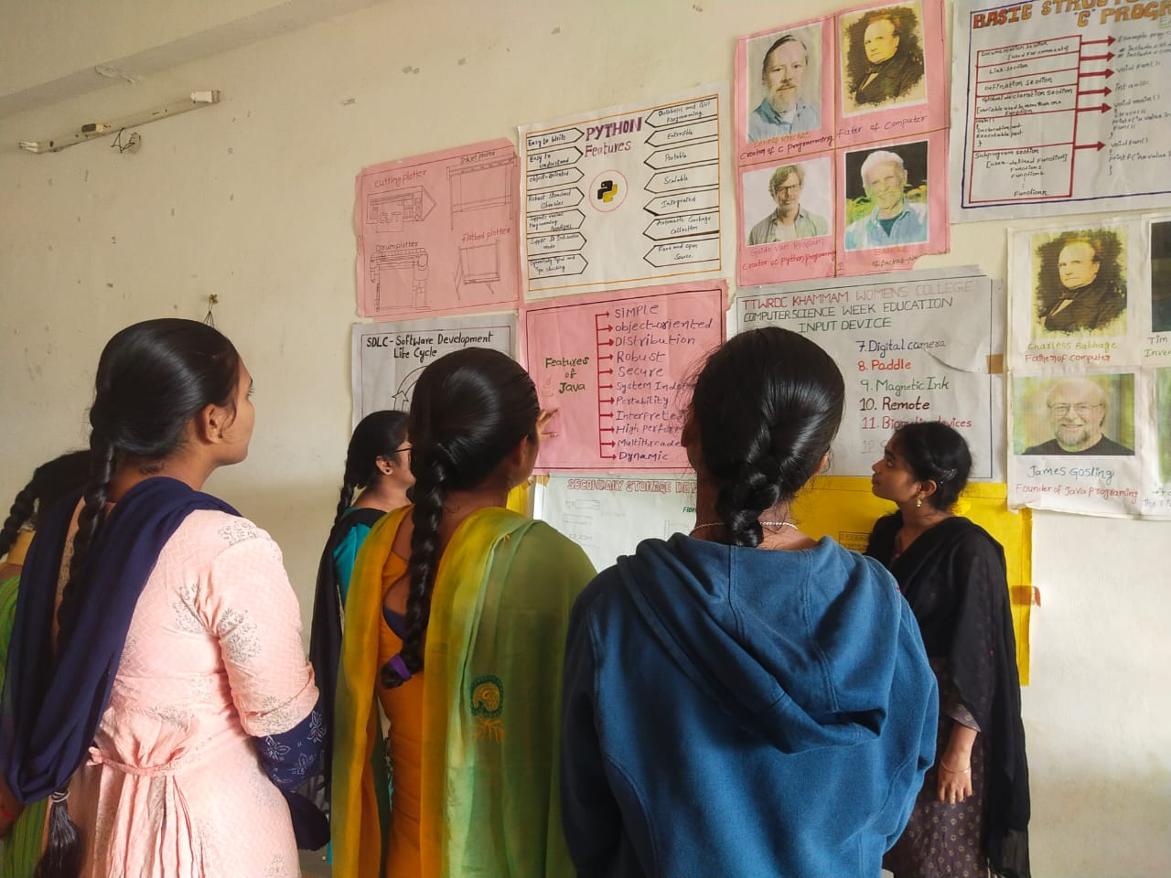

Department of computer science has conducted poster presentation competition for the first year students on the topic hardware parts of computer.
All the students has learned about the internal parts of the computer. With this activity they got knowledge and participated enthusiastically.

WORK SHOP

TOPIC : WORK SHOP ONHARDWARECOMPONENTS
DATE : 23-11-2018
PARTICIPANTS : IBS.C-MPCS&B.COM(CA)

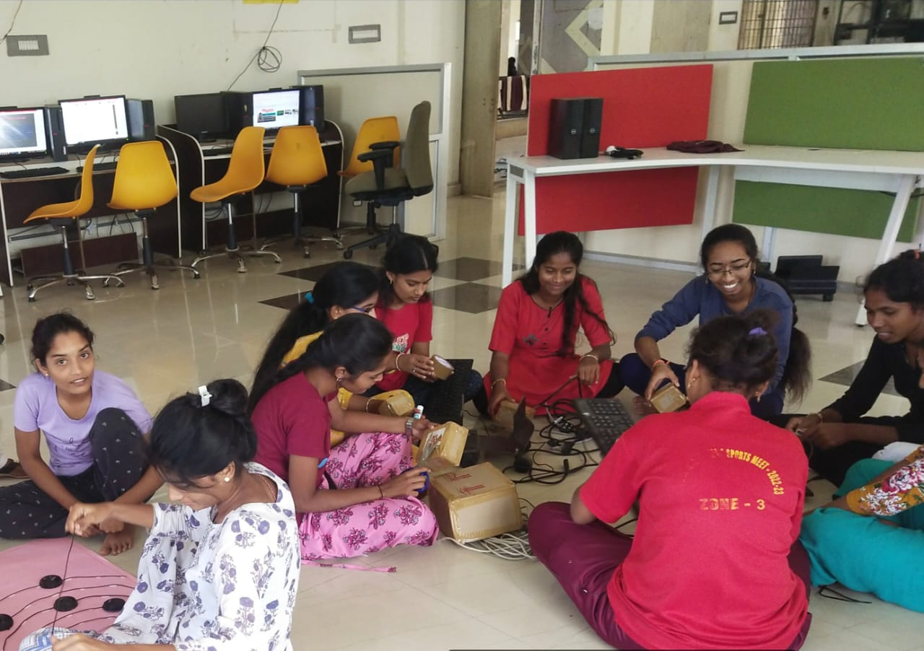

As part of departmental activities, we department of Computer Science conducted hardware componentsCraftPreparationforHardwareExhibition.

  - InthisprogramIB.SC-MPCS&B.Com(CA),studentsforpreparingHardwareComponentslikeMonitor,CPU,Keyboard,Mouse,Motherboard,Heatfan,RAM,Speakersetc.,
  - This Craft activity helps students to gain knowledge on how to make items from wastefrom best and also gain practical knowledge on each hardware components and theirusage.

QUIZCOMPETITION

TOPIC : BASICS OF COMPUTERS
DATE : 28/07/2018
PARTICIPANTS : I YEARS

A quiz is a form of game or mind sport in which players attempt to answer questions correctly on one or several topics. Quizzes can be used as a brief assessment in education and similar fields to measure growth in knowledge, abilities, and skills, or simply as a hobby. They can also be televised for entertainment purposes, often in a game show format.

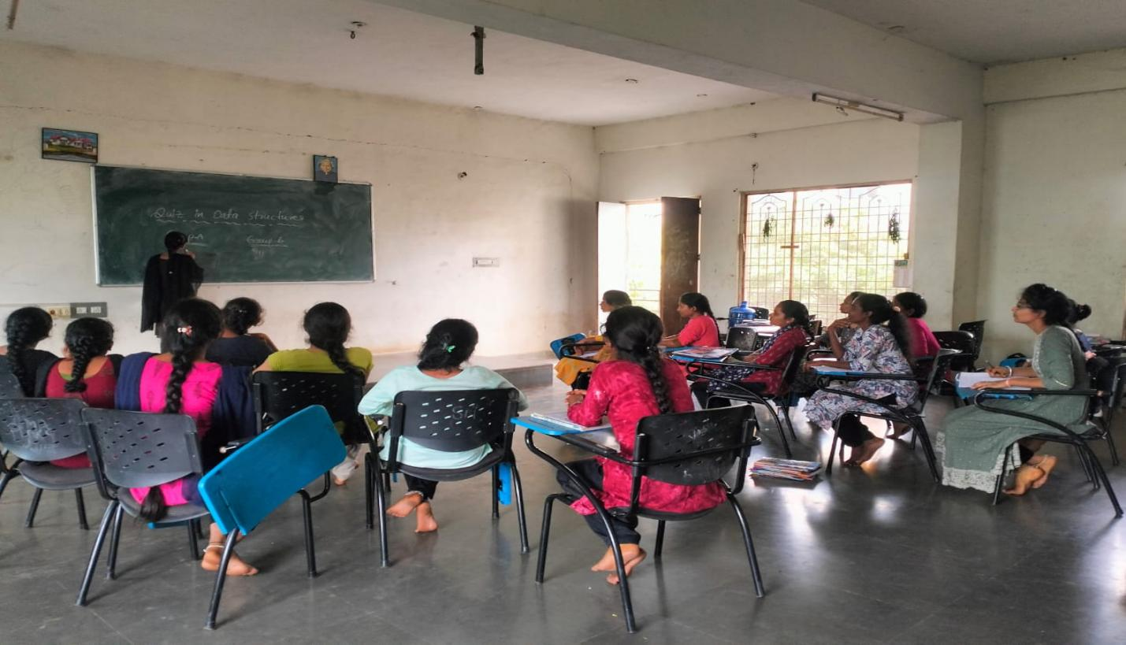
  - We department of Computer Science conducted quiz on Basic Computer Skills to I&II B.SC-MPCS&B.COM(CA).
  - StudentshaveparticipatedinthisQuizveryenthusiasmand donewell.
  - BythisQuizcompetitionstudentscanabletoknow aboutbasiccomputeroperationslikehow to shutdown&startcomputer,shortcutkeys etc.,
  - Bytheend ofthe sessionstudents gettheBASIC computer basics.

SEMINAR

DATE | NATURE OF  ACTIVITY | TOPIC | NAME OF THE  LECTURES INVOLVED | DETAILS OF  STUDENTS | NO OF STUDENTS  PARTICIPATED
12.09.2018 | Seminar | Input DevicesOutput Devices | Nousheen  Fatheema | B.Neelavathi  645194207 | 25
V.Laxmi Prabha
645194224

TOPIC:INPUT DEVICES AND OUTPUT DEVICES
DATE:12-09-2018
PARTICIPANTS:I SEM MPCS

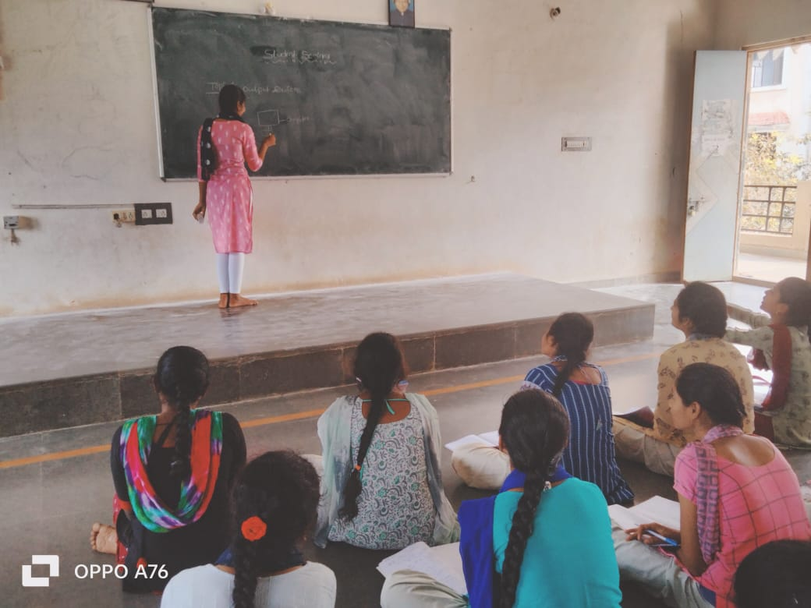
Name of the Student: B.Neelavathi(645194207)- I SEM MPCS
Contents Covered by Student:
Input device enables the user to send data, information, or control signals to a computer. The Central Processing Unit (CPU) of a computer receives the input and processes it to produce the output.
Some of the popular input devices are:
- Keyboard
- Mouse
- Scanner
- Joystick
- Light Pen
Seminar Topic: OUTPUT DEVICES
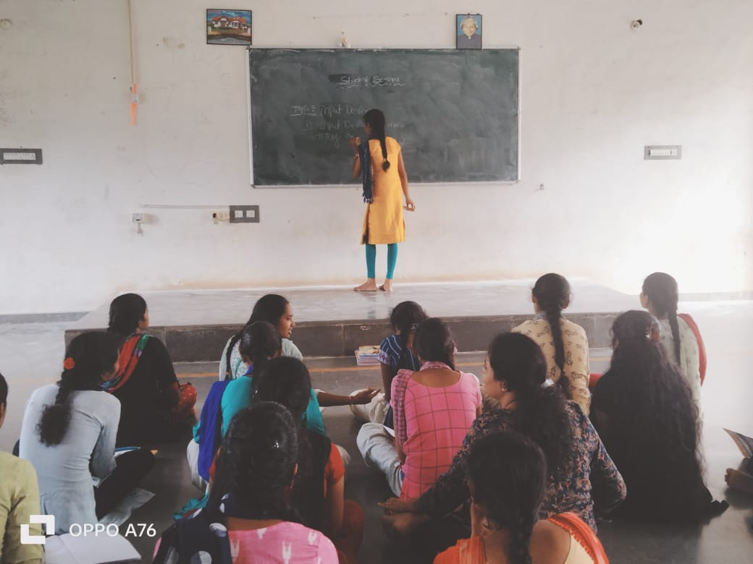

Name of the Student: V. Laxmi Prabha (645194224)
I SEM MPCS
Contents Covered by Student:

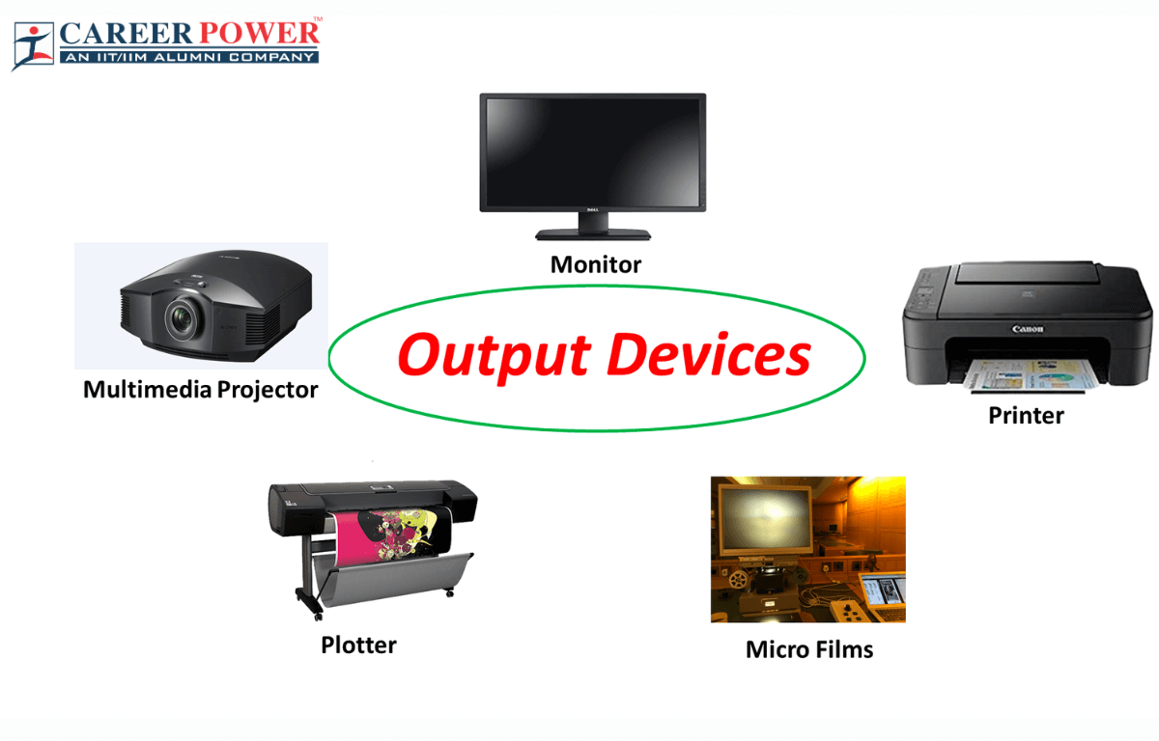
Output Devices of a Computer
We have already studied what is an output device and its definition. Now, let us have a look at the Output Devices of a computer. We know that computers use output devices to display results or information in different formats, including text, images, sound, or printed copies. Now let us know the top 10 output devices used for fetching results and information which are known as the output devices of a computer. Examples of Output Devices are-
Monitor,Printer,Speakers,Headphones,Projector.

GROUPDISCUSSION

DATE | NATURE OF  ACTIVITY | TOPIC | NAME OF THE  LECTURES INVOLVED | NO OF STUDENTS  PARTICIPATED
9/3/2018 | GROUP  DISCUSSION | Basics Of  Computer | Noushen Fathima | I Mpcs/  Bcom(CA)
12/28/2018 | GROUP  DISCUSSION | MS-OFFICE | Noushen Fathima | I MPcs/  Bcom(CA)

TOPIC : Basics of Computers
DATE : 03-092018

PARTICIPANTS : I MPCS,BCOM(CA)
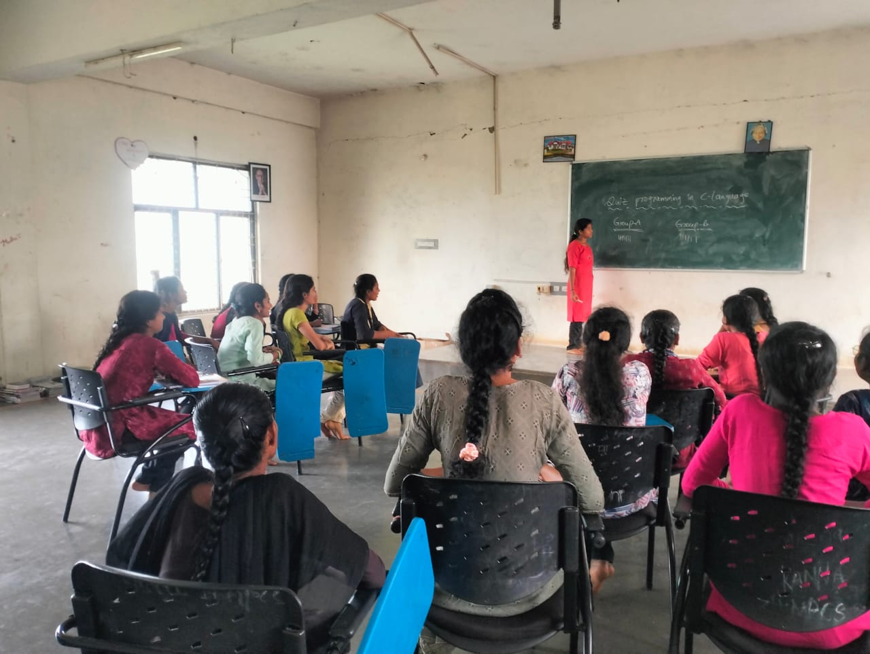

    - We the department of ComputerScience has conducted GroupDiscussiononBasics of Computers
Objectives:
    - Be well-prepared and knowledgeable.
    - Practice good communication skills.
    - Be confident and assertive.
    - Listen actively and attentively.
    - Start the discussion if possible.
    - Maintain eye contact with the group.
    - Stay calm and composed.
    - Respect others' opinions.

Wedividedstudentsinto4GroupsandnamedasGroupA,B,C&D. Group Discussion conducted for I B.SC-MPCS ,BCom C.A students and each group has discussed topics on data and classification, classification of computers, peripheral devices, memories, software and its types, hardware and operating system etc..StudentsparticipatedinGroupdiscussionveryenthusiasm.

GROUPDISCUSSION

TOPIC : MS-OFFICE
DATE : 28-12-2018
PARTICIPANTS : I MPCS,BCOM(CA)

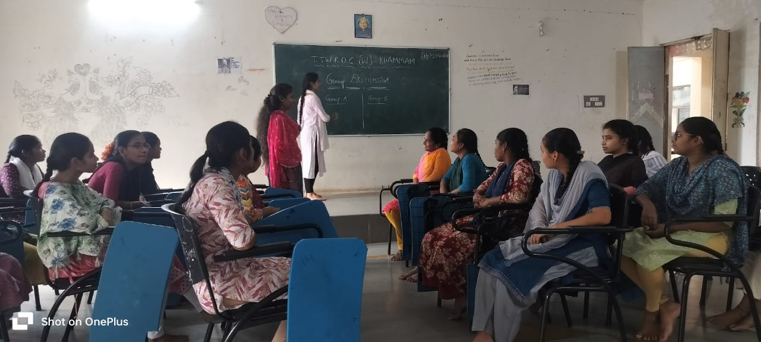

We the departmentofComputerScience has conductedGroupDiscussionon MS-Office
Objectives:
    - Be well-prepared and knowledgeable.
    - Practice good communication skills.
    - Be confident and assertive.
    - Listen actively and attentively.
    - Start the discussion if possible.
    - Maintain eye contact with the group.
    - Stay calm and composed.
    - Respect others' opinions.
Wedividedstudentsinto4GroupsandnamedasGroupA,B,C&D. Group Discussion conducted for I B.SC-MPCS ,BCom C.A Students and each group has discussed topics on MS Word,MS Excel, MS powerpoint functions, uses working icons, how to save, open, close, shortcuts etc..
StudentsparticipatedinGroupdiscussion with lot of interest and enthusiasm.

TELANGANATRIBALWELFARE RESIDENTIALDEGREECOLLEGE(GIRLS)KHAMMAM
(AffiliatedtoKakatiyaUniversity)
COLLEGECODE:645
Email:ttwrdcgirls.khammam@gmail.comPh.no:9491063083

DEPARTMENT OFCOMPUTERSCIENCEANDAPPLICATIONS

https://www.ttwrdcs.ac.in/Khammam/

*****

Department Activities 2019-20

*****
w

DEPARTMENTOF
COMPUTERSCIENCEANDAPPLICATIONS
https://ww.ttwrdcs.ac.in/Khammam/

GROUPDISCUSSION

DATE | NATURE OF  ACTIVITY | TOPIC | NAME OF THE  LECTURES INVOLVED | NO OF STUDENTS  PARTICIPATED
22/09/2019 | GROUP  DISCUSSION | Programing languege  in C | Noushen Fathima  P.Radha | II nd Mpcs/  Bcom(CA)

TOPIC : MS-OFFICE
DATE : 22/09/2019

PARTICIPANTS : Mpcs/Bcom(CA)
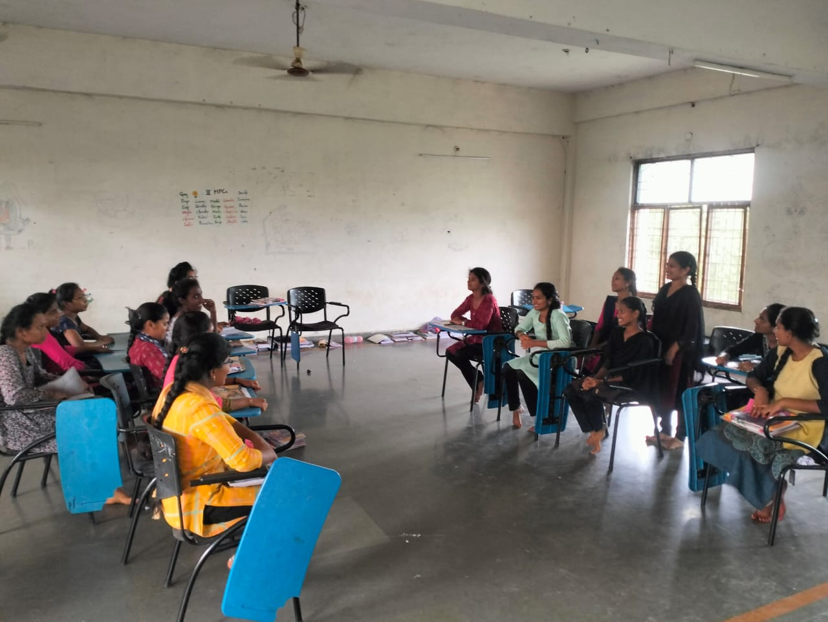

- We the department of Computer Science has conducted Group Discussionon MS-Office.

Objectives:
    - Be well-prepared and knowledgeable.
    - Practice good communication skills.
    - Be confident and assertive.
    - Listen actively and attentively.
    - Start the discussion if possible.
    - Maintain eye contact with the group.
    - Stay calm and composed.
    - Respect others' opinions.

We divided students into 4 Groups and named as Group A,B,C&D.
Group Discussion conducted for I B.SC-MPCS ,BCom C.A
Students and each group has discussed topics on MS Word,MS Excel, MS powerpoint functions, uses working icons, how to save, open, close, shortcuts etc..
Students participated in Groupdiscussion with lot of interest and enthusiasm.

EXTENSION LECTURE

TOPIC : TECHNOLOGY IN PRESENT DAYS
DATE : 10-02-2020
RESOURCE PERSON : Dr.D.Narasimha Rao

PARTICIPANTS : I/II / Years


TTWRDC(W),KHAMMAM College of computer science department organized a Guest Lecture on “TECHNOLOGY IN PRESENT DAYS” on 10th FEBRAUARY 2020. . The session was organized to give students brief overview of scope and career options in different computer science field and in different technologies. Sir has guided students about software job opportunities on current technologies and has given information on how to attend interview. Students from CS department attended the session.
. This session was highly useful to the students as they got familiarized on the TECHNOLOGY IN PRESENT DAYS and given awareness on how to face interviews. In this session —final year students are participated.
In the end of this session sir given interview tips to students and students are actively participated in this session.

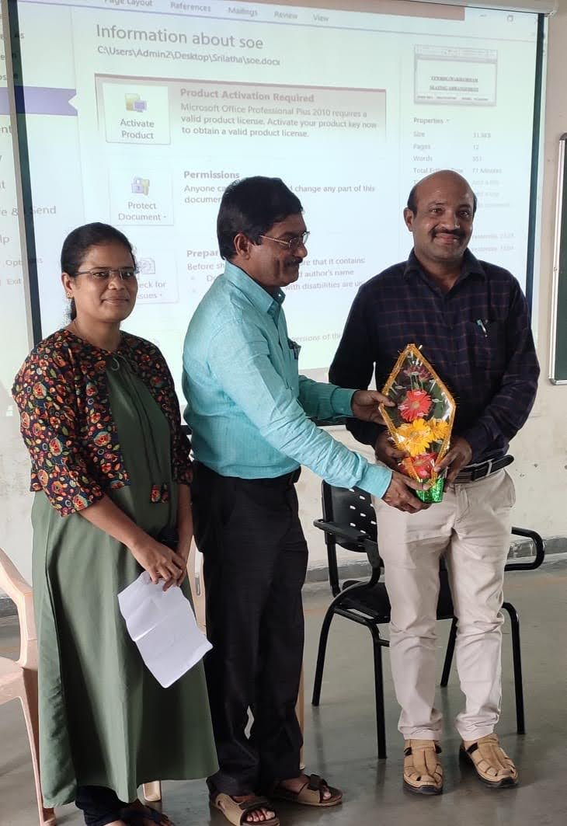

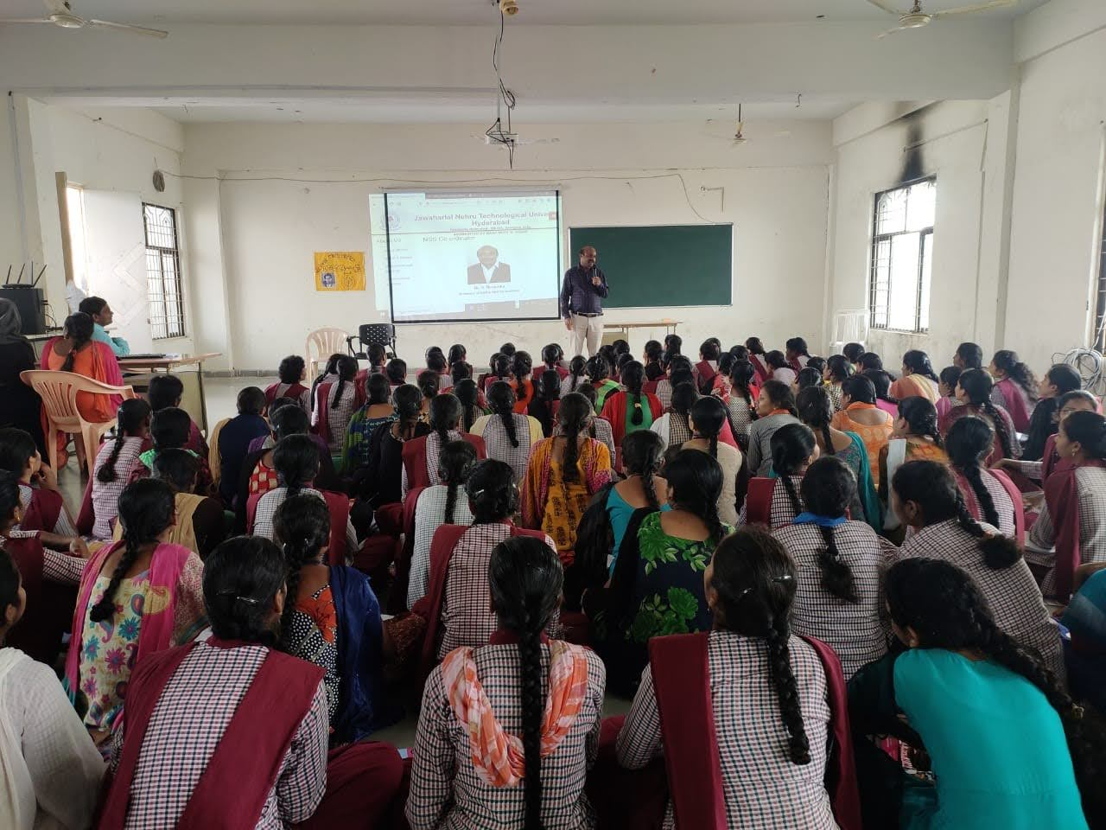

QUIZCOMPETITION

TOPIC : PROGRAMMING LANGUAGES C
DATE : 22-02-2019
PARTICIPANTS : II MPCS, IIBCOM(CA)

quiz is a form of game or mind sport in which players attempt to answer questions correctly on one or several topics. Quizzes can be used as a brief assessment in education and similar fields to measure growth in knowledge, abilities, and skills, or simply as a hobby. They can also be televised for entertainment purposes, often in a game show format.

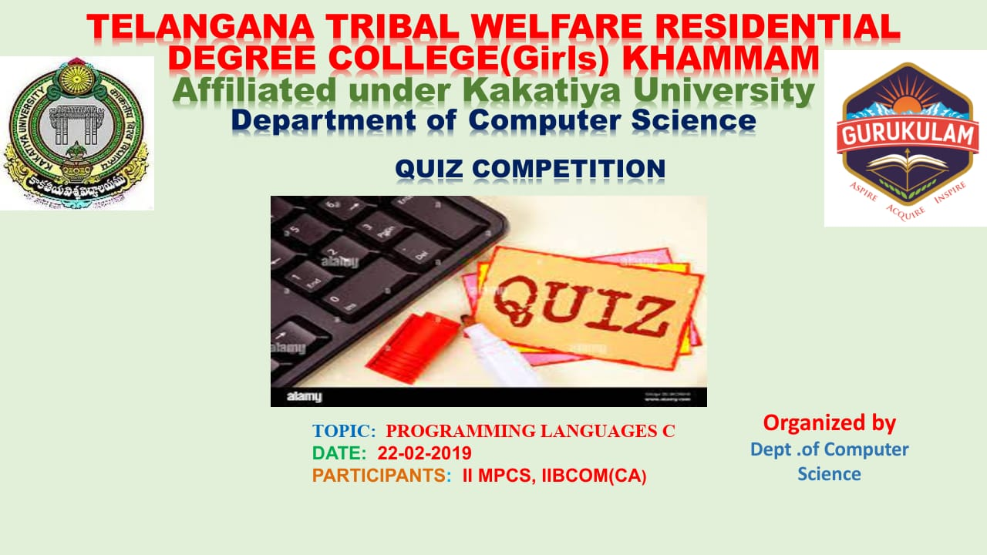

GROUPDISCUSSION

Topic: Programming in C
DATE :22-02-2019
PARTICIPANTS :II MPCS, IIBCOM(CA)

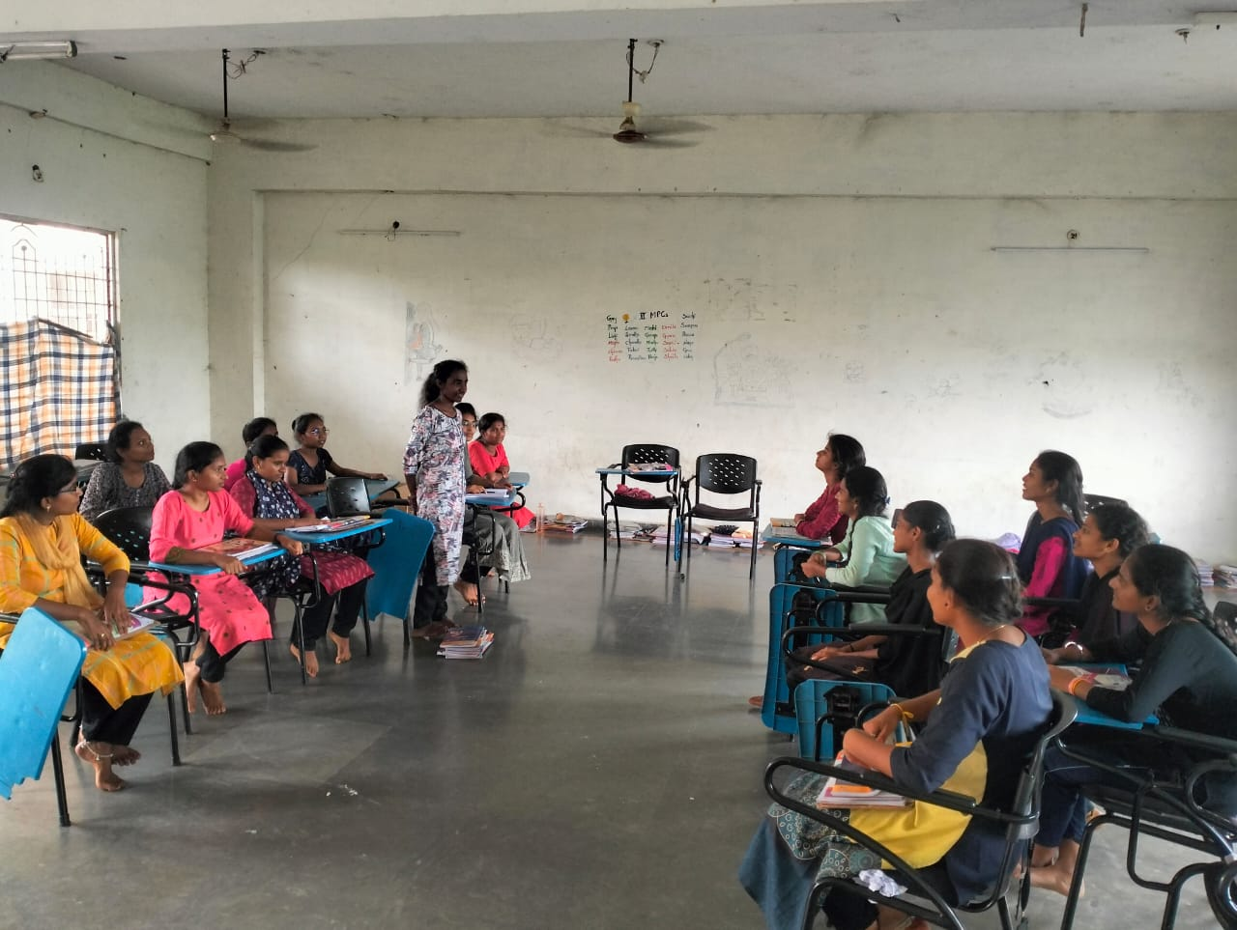

We the department ofComputerScience has conductedGroupDiscussionon programming languages C
Objectives:
    - Be well-prepared and knowledgeable.
    - Practice good communication skills.
    - Be confident and assertive.
    - Listen actively and attentively.
    - Start the discussion if possible.
    - Maintain eye contact with the group.
    - Stay calm and composed.
    - Respect others' opinions.

Wedividedstudentsinto4GroupsandnamedasGroupA,B,C&D.
Group Discussion conducted for II MPCS, IIBCOM(CA)

Students and each group has discussed topics on structured vs unstructured, procedural vs nonprocedural, data types, tokens, conditional and unconditional statements, loop control statements arrays, functions ,compilation, execution, debugging etc.
StudentsparticipatedinGroupdiscussion with lot of interest and enthusiasm.

STUDENT SEMINAR

DATE | NATURE OF  ACTIVITY | TOPIC | NAME OF THE  LECTURES INVOLVED | DETAILS OF  STUDENTS | NO OF STUDENTS  PARTICIPATED
2/12/2019 | Seminar | Arrays in c | P.RADHA | B.Renuka  645202206 | 22
3/13/2020 | Seminar | If statements | P.RADHA | L.Sravani  645202217 | 22
3/13/2020 | Seminar | operators in c | P.RADHA | P.Bhumika  645202224 | 22
3/13/2020 | Seminar | if statement in c | P.RADHA | G.Vani  645202207 | 22

TOPIC : Arrays in c
DATE : 2/22/2019
PARTICIPANTS : I -BCOM CA

Name of the Student: B.Renuka (645202206)I BCOM CA
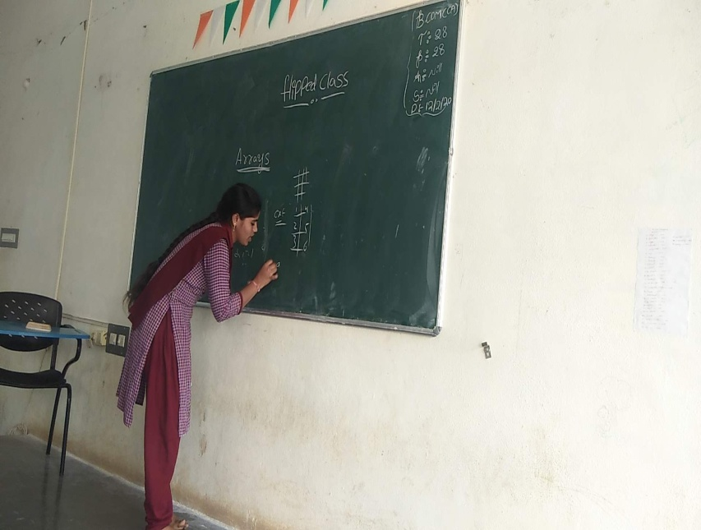

CONTENT COVERED BY STEDENT: ARRAYS IN C LANGUAGE
I have conduced student seminar to encourage them towards teaching and also to get rid off-stage fear.
- In this session B.RENUKA student of I.B.COM CA Has participated. She has given seminar on ARRAYS IN C LANGUAGE She interacted with the students very well .
- First she given introduction of the topic.
- Next she explained following points
1 .ARRAYS SYNTAX
2. USES OF ARRAYS

Department Activities 2020-21

Quiz Competition

TOPIC:PROGRAMMING IN C++

DATE:30-09-2020
PARTICIPANTS :II & IV Semester
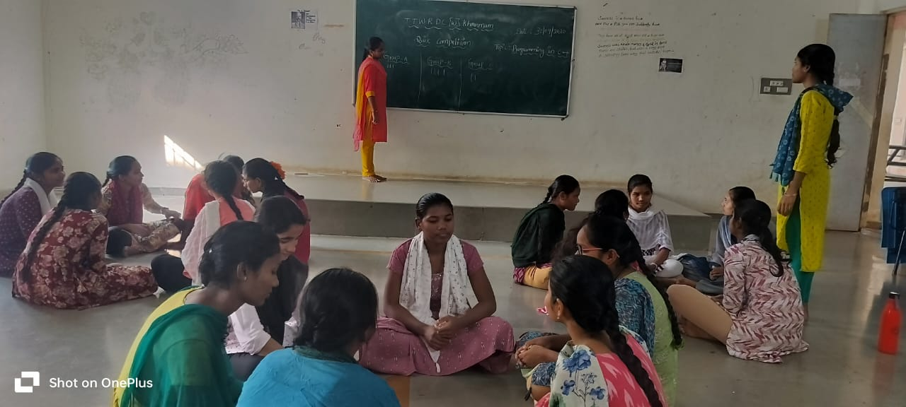

A quiz is a form of game or mind sport in which players attempt to answer questions correctly on one or several topics. Quizzes can be used as a brief assessment in education and similar fields to measure growth in knowledge, abilities, and skills, or simply as a hobby. They can also be televised for entertainment purposes, often in a game show format.

GROUPDISCUSSION

TOPIC:programing lagueges c c++, DBMS,Java and Python

DATE:30-01-2021
PARTICIPANTS:III rd Mpcs/Bcom(CA)

DATE | NATURE OF  ACTIVITY | TOPIC | NAME OF THE  LECTURES INVOLVED | NO OF STUDENTS  PARTICIPATED
30-01-2021 | GROUP  DISCUSSION | programing lagueges c c++,  DBMS,Java and Python | Noushen Fathima  P.Radha | III rd Mpcs/  Bcom(CA)S

- We the department of Computer Science has conducted Group Discussionon Programming languages C, C++,DBMS, Java and Python.

Objectives:
    - Be well-prepared and knowledgeable.
    - Practice good communication skills.
    - Be confident and assertive.
    - Listen actively and attentively.
    - Start the discussion if possible.
    - Maintain eye contact with the group.
    - Stay calm and composed.
    - Respect others' opinions.

We divided students into 4 Groups and named as Group A,B,C&D.
Group Discussion conducted for II B.SC-MPCS ,BCom C.A
Students and each group has discussed topics on internet definition,uses, functions, dangers, benefits for students , apps like youtube, google search etc.
Students participated in Group discussion with lot of interest and enthusiasm.

NATIONAL SCIENCE DAY

DATE :28-02-2021

PARTICIPANTS: All students
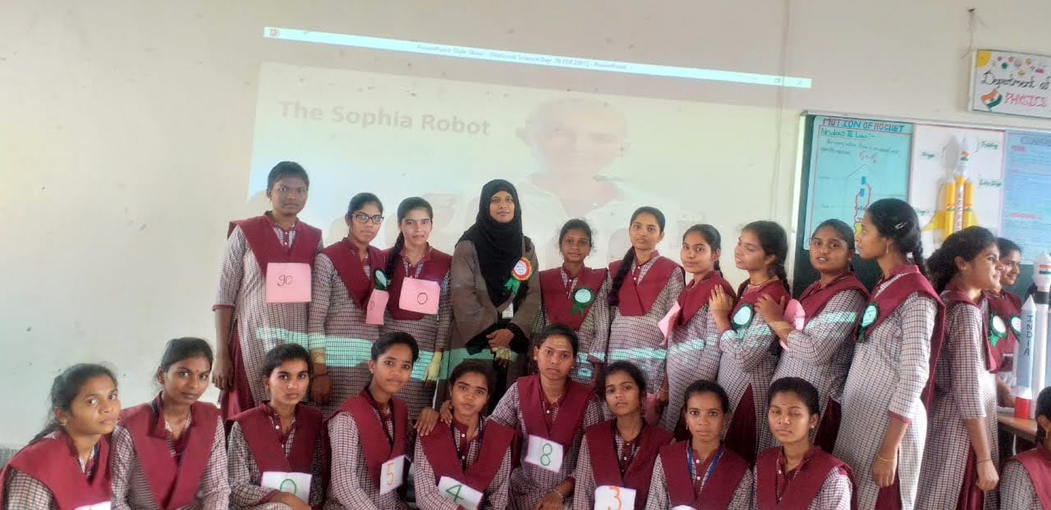
Department of computer science students has celeberated National Science Day. Our students has exhibited poster presentation, shown modules on the currnet technologies. All the students has shown their effort for the success of the program. Departmetnt staff has guided in all aspects.

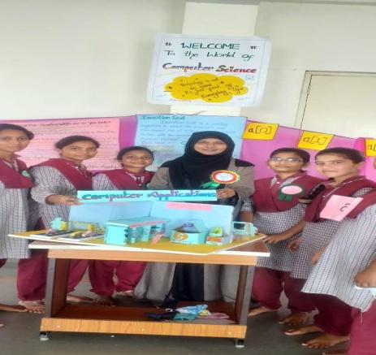
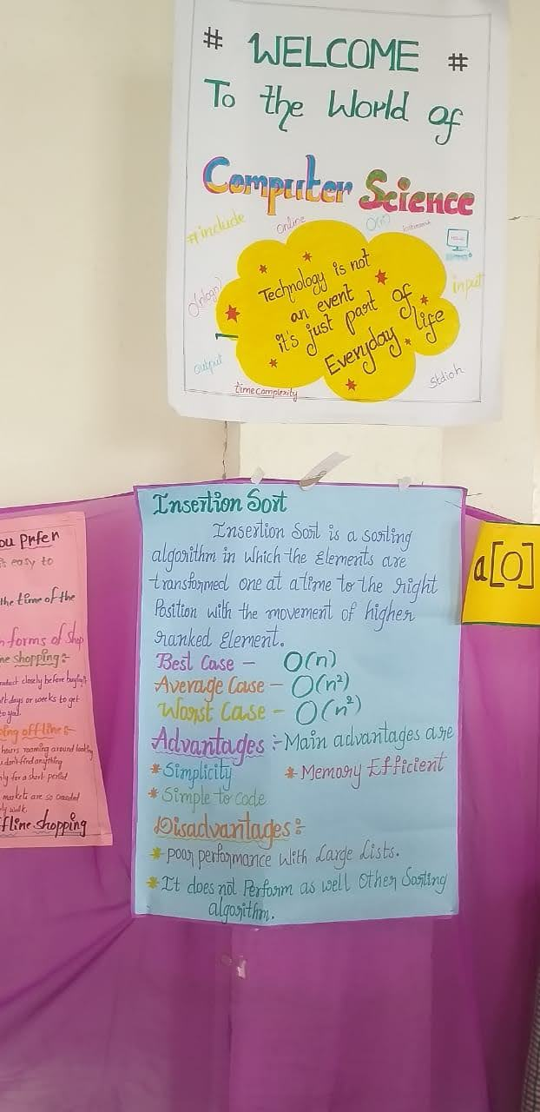

GROUP DISCUSSION

TOPIC:MS-OFFICE
DATE :25-03-2021
PARTICIPANTS :I MPCS, B.COM(CA)

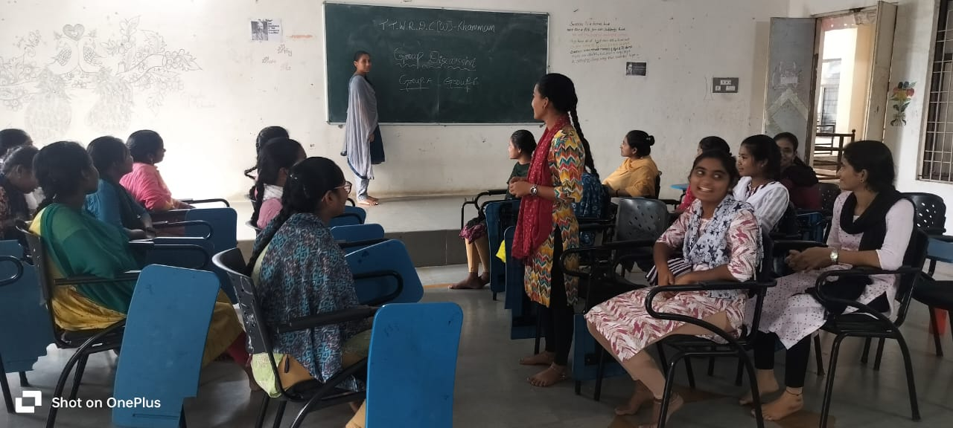

    - We the departmentofComputerScience has conductedGroupDiscussionon MS-Office
Objectives:
    - Be well-prepared and knowledgeable.
    - Practice good communication skills.
    - Be confident and assertive.
    - Listen actively and attentively.
    - Start the discussion if possible.
    - Maintain eye contact with the group.
    - Stay calm and composed.
    - Respect others' opinions.

Wedividedstudentsinto4GroupsandnamedasGroupA,B,C&D.
Group Discussion conducted for I B.SC-MPCS ,BCom C.A
Students and each group has discussed topics on MS Word,MS Excel, MS powerpoint functions, uses working icons, how to save, open, close, shortcuts etc..
Students has participated in group discussion with lot of interest and enthusiasm.

EXTENSION LECTURES

ACADEMIC  YEAR | RESOURCE PERSON | TOPIC COVERED
06-06-2021 | Dr.Venugopal Reddy | DBMS
16-06-2021 | Mr.Mohammad Nayeemuddin | Emerging Trends In Technology

WEBINAR

TOPIC: Database Management System (DBMS)
DATE : 06-06-2021
PARTICIPANTS : All CS Students
RESOURCE PERSON: Dr.Venugopal Reddy

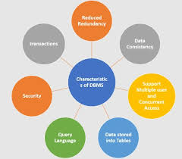

TTWRDC(W),KHAMMAM College of computer science department organized a Extension Lecture on “Database Management System” on 6th JUNE 2021. . The session was organized to give students brief overview of database management system basic topics and how to write ,create SQL database. Sir has given clear guidance of using SQL commands, ER diagrams and Relational models. Sir has given information about real time applications. Students from CS department attended the session.
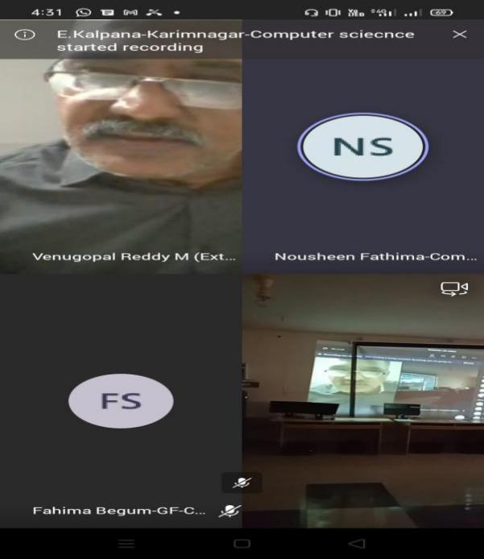

This session was highly useful to the students as they got familiarized on the Database management systems and given awareness on how to do coding using SQL. In this session —all the computer science students are participated.
In the end of this session sir given interview tips to students and students are actively participated in this session.

TELANGANATRIBALWELFARE RESIDENTIALDEGREECOLLEGE(GIRLS)KHAMMAM
(AffiliatedtoKakatiyaUniversity)
COLLEGECODE:645
Email:ttwrdcgirls.khammam@gmail.comPh.no:9491063083

DEPARTMENT OFCOMPUTERSCIENCEANDAPPLICATIONS

https://www.ttwrdcs.ac.in/Khammam/

*****

Department Activities 2021-22

*****

DEPARTMENTOF
COMPUTERSCIENCEANDAPPLICATIONS
https://ww.ttwrdcs.ac.in/Khammam/

WEBINAR

TOPIC: EMERGING TRENDS IN TECHNOLOGY

DATE:16-06-2021

PARTICIPANTS:All CS students
RESOURCE PERSON: Mr.Mohammad Nayeemuddin

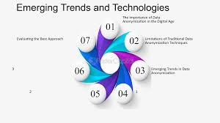

TTWRDC(W),KHAMMAM College of computer science department organized a Guest Lecture on “EMERGING TRENDS IN TECHNOLOGY” on 16th JUNE 2021. . The session was organized to give students brief overview of scope and career options in different computer science field and in different technologies. Sir has guided students about software job opportunities on current technologies and has given information on how to attend interview. Students from CS department attended the session.
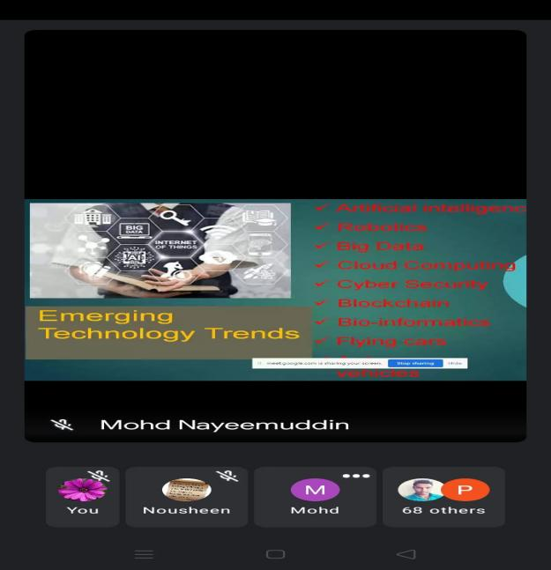

.

This session was highly useful to the students as they got familiarized on the EMERGING TRENDS IN TECHNOLOGY and given awareness on how to face interviews. In this session —final year students are participated. Emerging technologies are technologies whose development, practical applications, or both are still largely unrealized. These technologies are generally new but also include old technologies finding new applications. Emerging technologies are often perceived as capable of changing the status quo.
In the end of this session sir given interview tips to students and students are actively participated in this session.

SEMINAR 2021-2022

DATE | NATURE OF  ACTIVITY | TOPIC | NAME OF THE  LECTURES INVOLVED | DETAILS OF  STUDENTS | NO OF STUDENTS  PARTICIPATED
17-11-2021 | SEMINAR | E BANKING | P.RADHA | K.RAJYA  LAXMI | 22
02-12-2021 | SEMINAR | SECONDARY  STORAGE DEVICES | P.RADHA | D.TEJASRI  645222209 | 30
24-11-2021 | SEMINAR | OPERATING  SYSTEM AND TYPES | P.RADHA | S.SHESHMA  645222227 | 30
27-11-2021 | SEMINAR | ATTRIBUTES  AND ITS TYPES | P.RADHA | G.NAVYA  645212213 | 30
22-04-2022 | SEMINAR | PYTHON  OPERATORS | NOUSHEEN  FATHIMA | D.GANGA  645224310 | 20
14-05-2022 | SEMINAR | JAVA SCRIPT  INTRODUCTION | P.RADHA | SK.JANI BEGUM  645204235 | 22
18-05-2022 | SEMINAR | DATATYPES IN  SQL | P.RADHA | B.KEERTHIKA  645214104 | 25
26-05-2022 | SEMINAR | FUNCTIONS  IN C | P.RADHA | D.TEJASRI  645222209 | 30

SEMINAR

TOPIC : E BANKING

DATE : 17-11-2021

PARTICIPANTS: II.B.COM CA


Content covered byK.RAJYA LAXMI
The Automated Teller Machines are computerized telecommunication device that provides a financial institutions customers a method of financial transactions in a public space without the need for a human clerk or bank teller.
These are meant for balance enquiries, cash withdrawals and many other facilities depending upon policies of the bank. This requires a valid Customer Id and password to log in and is therefore safe to be used.

Debit Card• Debit Cards is another advanced technology of the electronic banking. Now-adays, these cards are the multi-purpose cards and can be used in ATMs for balance 5 enquiry and cash withdrawal or can be used for easy shopping at various counters. Debit Cards ensure the automatic deduction of amount from the account just by scratching it on the machine.
Credit Card A credit card system is a type of retail transaction settlement and credit system, named after the small plastic card issued to users of the system.
In the case of credit cards, the issuer lends money to the consumer.
Credit cards become very popular in India with the introduction of foreign banks in the country. Smart Card•

A Smart card is a plastic card used for storing and retrieving personal information. Normally, it is the size of a credit card and contains electronic memory and possibly an embedded integrated circuit. Kiosk machine

SEMINAR

TOPIC : ATTRIBUTES AND ITS TYPES
DATE : 27-11-2021
PARTICIPANTS : II.B.COM CA

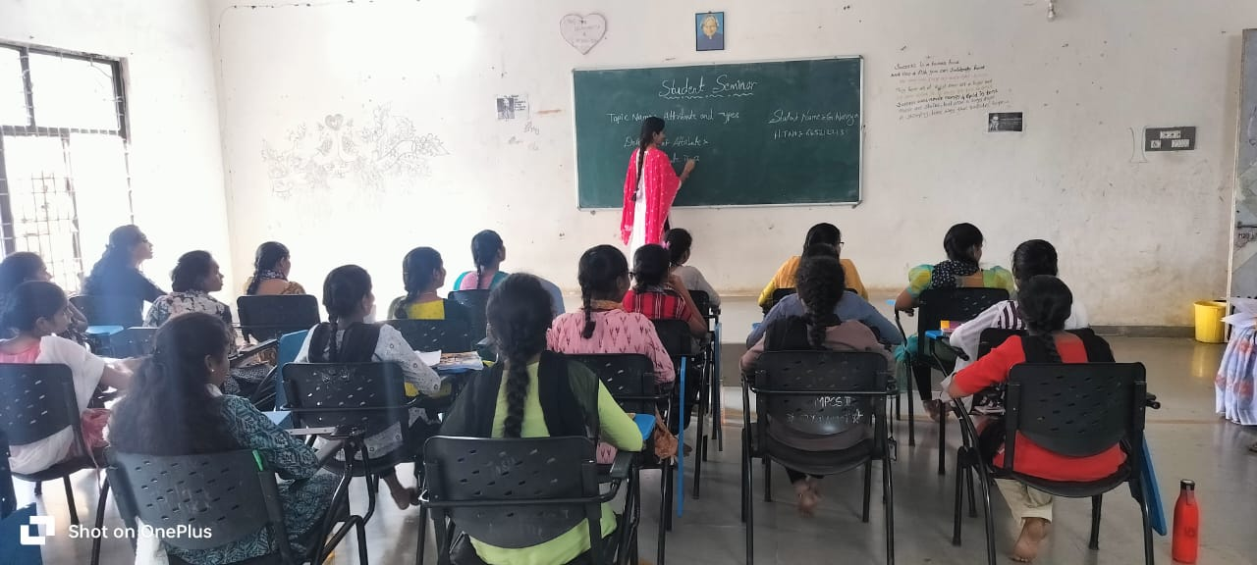

Types of Attributes
There are different types of attributes as discussed below-
- Simple Attribute
- Composite Attribute
- Single-Valued Attribute
- Multi-Valued Attribute
- Derived Attribute
- Complex Attribute
- Stored Attribute
- Key Attribute
- Null Attribute
- Descriptive Attribute

QUIZ COMPETITION
TOPIC : Programming in Java.
DATE : 17.11.2021.
PARTICIPANTS : III/ V Sem.

A quiz is a form of game or mind sport in which players attempt to answer questions correctly on one or several topics. Quizzes can be used as a brief assessment in education and similar fields to measure growth in knowledge, abilities, and skills, or simply as a hobby. They can also be televised for entertainment purposes, often in a game show format.
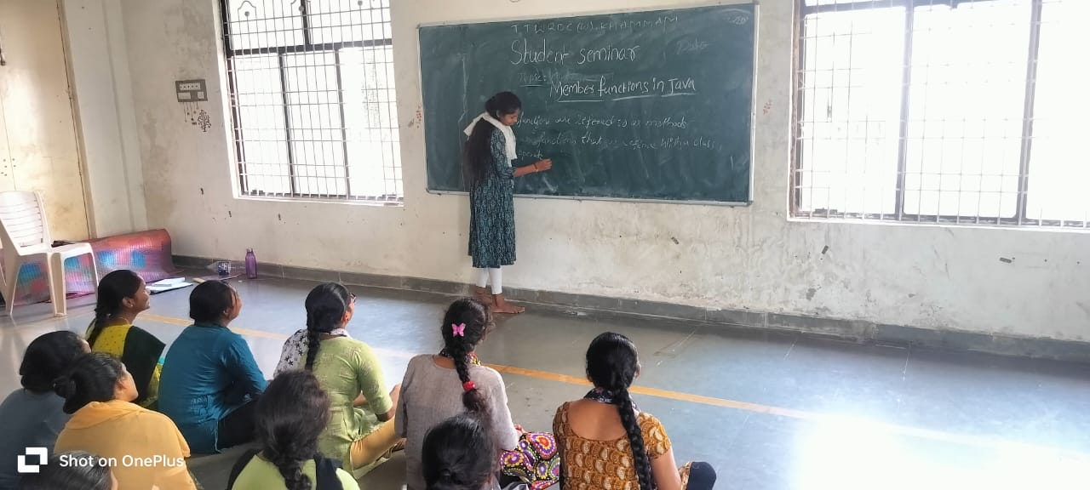

WORKSHOP

.
TOPIC:HARDWARE PERIPHERAL
DATE:DEC-11-2021
PARTICIPANTS:I.B.COM CA

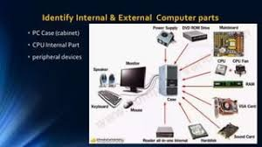

As part of departmental activities, we department of Computer Science conducted hardware componentsCraftPreparationforHardwareExhibition.
  - InthisprogramIB.SC-MPCS&B.Com(CA),studentsforpreparingHardwareComponentslikeMonitor,CPU,Keyboard,Mouse,

  - Motherboard,Heatfan,RAM,Speakersetc.,
  - This Craft activity helps students to gain knowledge on how to make items from wastefrom best and also gain practical knowledge on each hardware components and theirusage.

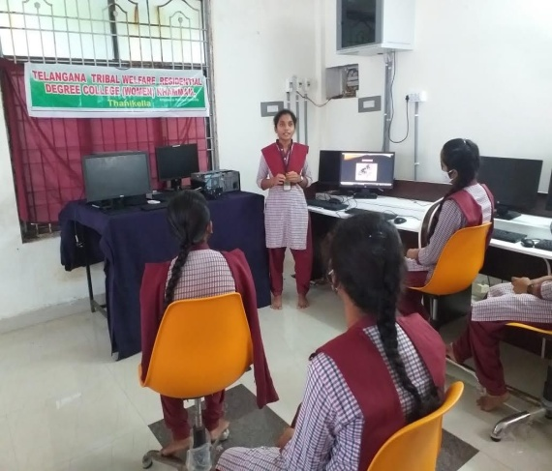
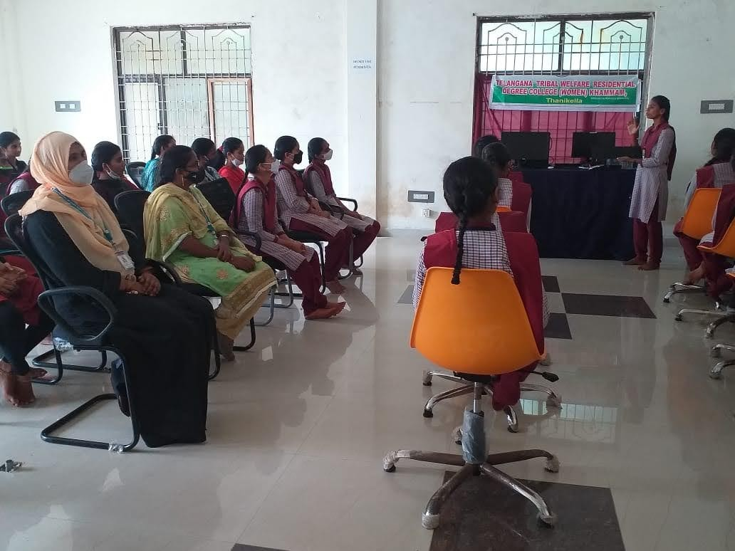

.

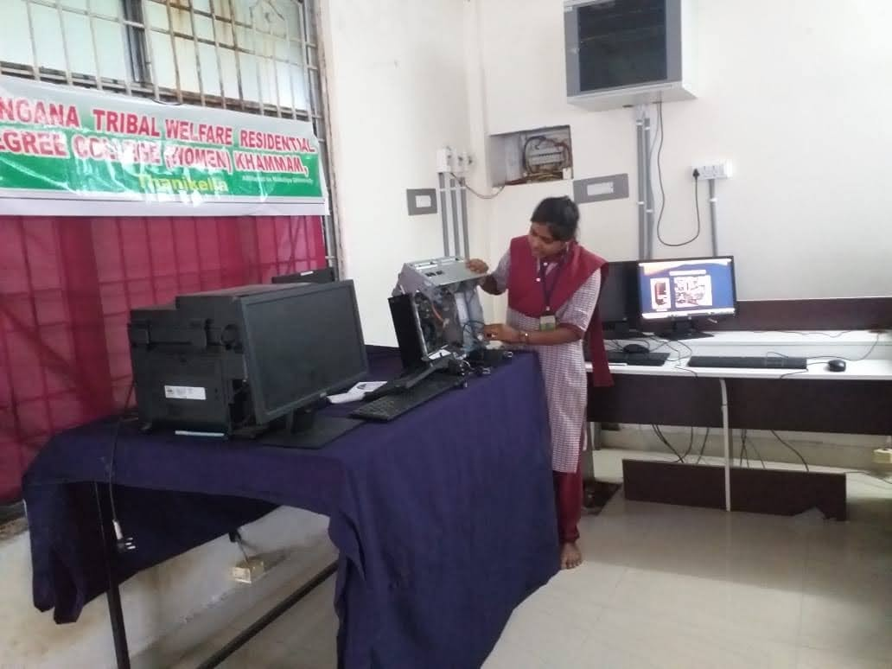

EXTENSION LECTURE

ACADEMIC  YEAR | RESOURCE PERSON | TOPIC COVERED
09-04-2022 | Mr.Y.Mani deep | Wed Technologies

TOPIC: Wed Technologies

DATE:-09-04-2022

PARTICIPANTS:All CS students
RESOURCE PERSON: Mr.Y.Mani deep

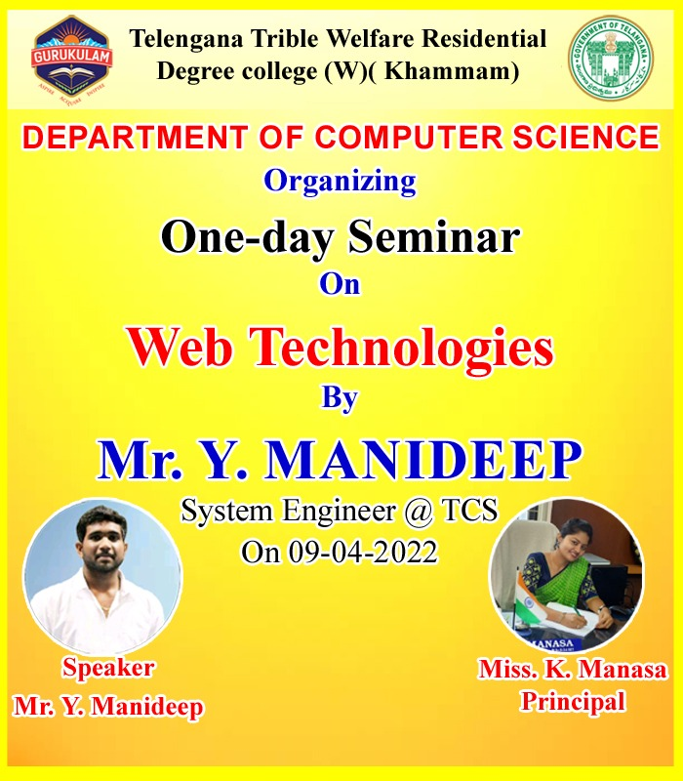

Objectives:
- The computer science Department organized different seminars and extension lectures for the students in different Topics.
- The guest lecture may have to spread the knowledge to the students for better feature.
- To help students and faculty to gain the latest concepts, practices, trends etc in core subjects
- To facilitate effective achievement of certain course outcomes
- It is helps the students to improve knowledge.
- To afford an opportunity to students to network with people from other colleges.

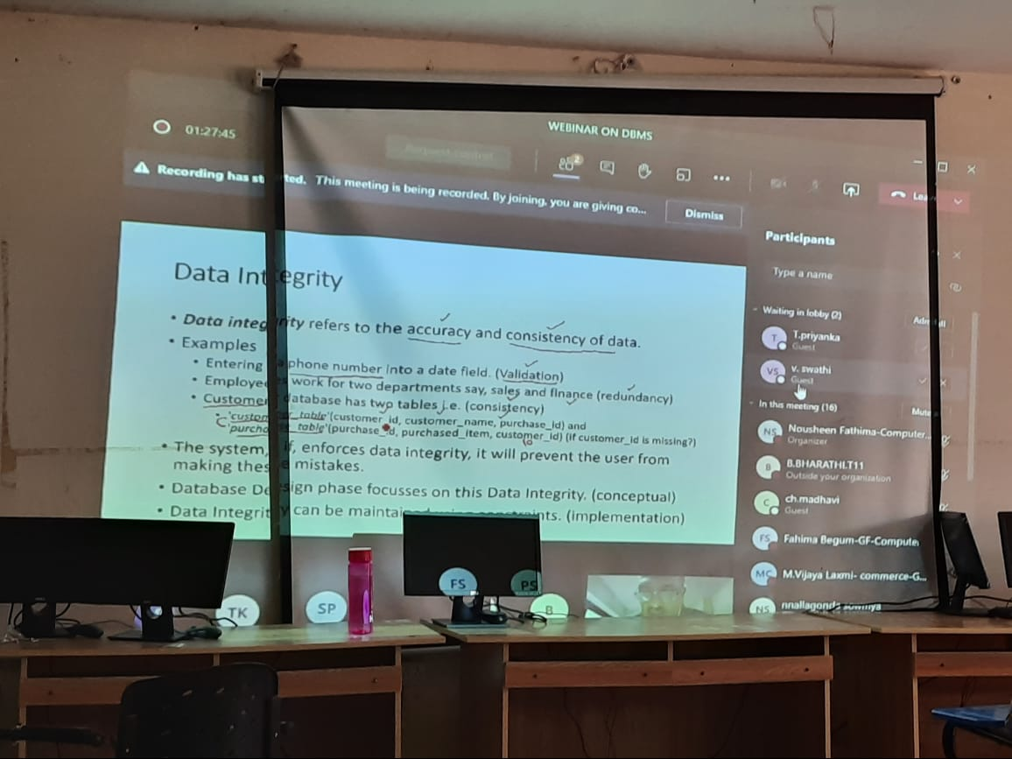
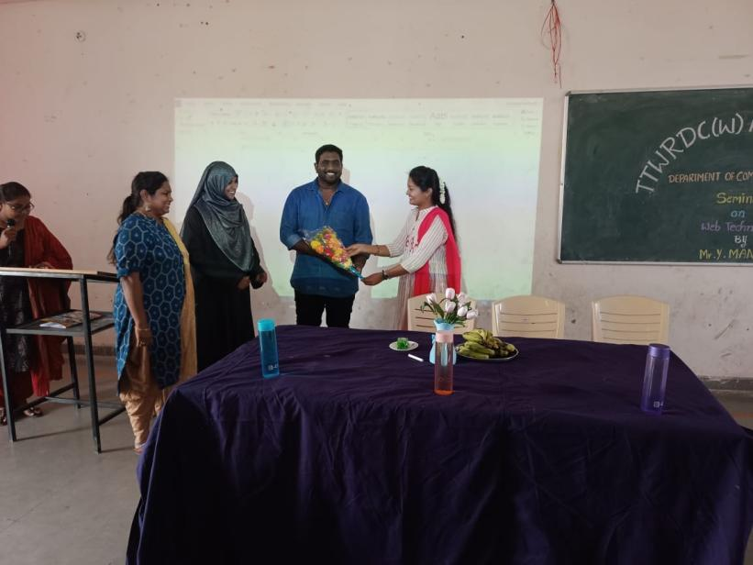

The Practice:

- Seminars are organised depending on need and importance of including Extension lectures as part of Curriculum delivery.
- The Keydecisions were taken regarding which subjects would compulsorily have guest sessions, frequency of such sessions in each subject, who [designation etc] could be called for such sessions, duration of such sessions, and the kind of topics to be covered and whether it would be for select students of a course or for the general Student body.
- Processes and documents for inviting guest lecturers, conducting guest lectures, payments, recording such events, feedback of students etc were decided upon.

FIELD TRIP

TOPIC: INTERACTION BETWEEN THE STUDENTS AND THE
WORKING INDUSTRY
DATE:05-05-2022
LOCATION:IT HUB, KHAMMAM
PARTICIPANTS:I & II BS.C-MPCS

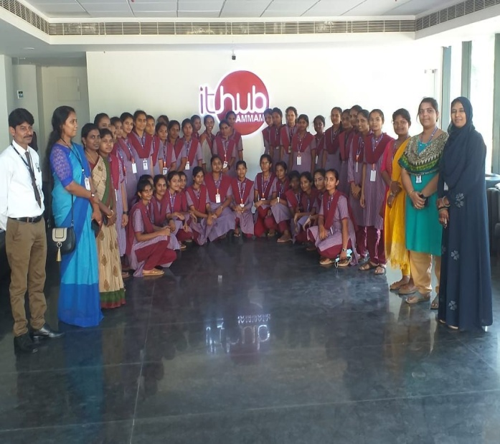

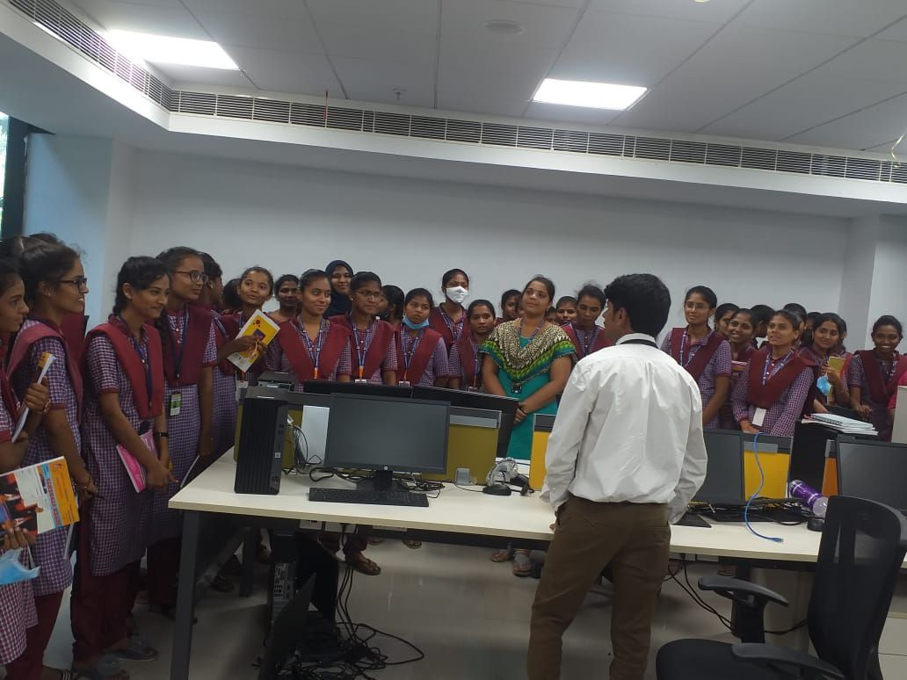
Objectives
- The objectives of the trip was to get to know the working environment of IT industries, operations, emerging technologies and skills required for the students to choose their carrier in IT Industry.
- Field trips make learning more engaging, memorable, and relevant. Furthermore, they promote critical thinking, enhance observational skills, and nurture a sense of curiosity and wonder.
- Outdoor education emphasizes holistic development. Activities such as team-building exercises, problem-solving challenges, and nature walks nurture not just cognitive skills but also emotional, social, and physical well-being. Students learn resilience, adaptability, and interpersonal skills in real-time, real-world scenarios.
BEST PRACTICE
- Main aim of Field Trip is to provide an exposure to students about practical working environment.
- They also provide students a good opportunity to gain full awareness about industrial practices. Through Field Trip students get awareness about new technologies.

Department Activities 2022-23

QUIZ COMPETITION

TOPIC : Programming in C++.
DATE : 17.11.2022.
PARTICIPANTS : III & VSem.

A quiz is a form of game or mind sport in which players attempt to answer questions
correctly on one or several topics. Quizzes can be used as a brief assessment in education and
similar fields to measure growth in knowledge, abilities, and skills, or simply as a hobby. They
can also be televised for entertainment purposes, often in a game show format.

SEMINAR 2022-2023
DATE | NATURE OF  ACTIVITY | TOPIC | NAME OF THE  LECTURES INVOLVED | DETAILS OF  STUDENTS | NO OF STUDENTS  PARTICIPATED
26-11-2022 | Seminar | Datatypes  in c | D.Sujatha | B. Srilaxmi  645234107 | 15
05-12-2022 | Seminar | Collision strategies of hash table | P.Radha | Sameera | 22
09-12-2022 | Seminar | Merge sort | P.Radha | T. Samatha | 22
12-12-2022 | Seminar | Tree terminal ogy | P.Radha | B. Gowthami | 20
12-12-2022 | Seminar | BFS, DFS | P.Radha | Suchitra | 20
14-12-2022 | Seminar | Looping Statements | H.Rambabu | H. Renuka 645234112 | 21
15-12-2022 | Seminar | Selection Sort | P.Radha | J. Thulasi | 22
17-12-2022 | Seminar | Secondary storage devices | P.Radha | Chitti | 29
28-12-2022 | Seminar | types of arrays | H.Rambabu | G. Shireesha 645234112 | 19
30-12-2022 | Seminar | input output devices | P.Radha | B. Anusha | 30
05-01-2023 | Seminar | black daigram of computer | P.Radha | T. Jhansi | 30
07-01-2023 | Seminar | parameter passing techniques | H.Rambabu | B. Sathwika 645234109 | 20
28-01-2023 | Seminar | pointers | H.Rambabu | l.Mounika 645234115 | 15
22-02-2023 | Seminar | trees data structure | H.Rambabu | B. Gangothri 645224101 | 26
01-03-2023 | Seminar | relational algebra | H.Rambabu | B. Lavanya 645224106 | 25
01-03-2023 | Seminar | binary search trees | H.Rambabu | B. Gowthami 645224104 | 26
09-03-2023 | Seminar | oops concepts | H.Rambabu | B. Srinithya 645234118 | 20
15-03-2023 | Seminar | spanning trees | H.Rambabu | B.Chandhana 645224103 | 23
15-03-2023 | Seminar | forms in html | V.Bhanu  prasad | B. Jamuna 645222205 | 27
18-03-2023 | Seminar | types of constructors | H.Rambabu | D. Poojitha 645234110 | 18
20-03-2023 | Seminar | operators in c | H.Rambabu | M. Kavya 645234119 | 21
21.03.2023 | Seminar | oops concepts in C++ | V.Bhanu  prasad | H. Hymavathi 645231001 | 7
31-03-2023 | Seminar | types of inheritance | H.Rambabu | B. Srilatha 645234108 | 20
06-04-2023 | Seminar | DFS , BFS | H. Rambabu | B. Suchithra 645224102 | 24
12-04-2023 | Seminar | Css in html | V.Bhanu  prasad | S. Shesma 645522227 | 27
14-04-2023 | Seminar | Polymorphism | H.Rambabu | M. Kavya 645234119 | 14
16-04-2023 | Seminar | Inheritance in C++ | V.Bhanu  prasad | N. Nageshwari 645231403 | 7
17-04-2023 | Seminar | Operators in java script | P.Radha | G. Lavanya | 20
20-04-2023 | Seminar | Data types in | P.Radha | B. Anusha | 30
21-04-2023 | Seminar | Control statement in java script | P.Radha | B. Swathi | 20
21-04-2023 | Seminar | Exeption handling | H.Rambabu | B. Sailaja 645234103 | 19
24-04-2023 | Seminar | Operators in c | P.Radha | A. Bhavana | 30
26-04-2023 | Seminar | If statement in c | P.Radha | l. Aruna | 30

STUDENT SEMINAR

S.NO | DATE | NAME OF THE ACTIVITY | TOPIC | STUDENT NAME | H.T.NO | NO OF STUDENT PARTICIPATED
1 | 05-12-2022 | SEMINAR | COLLISION STRATEGIES OF HASH TABLE | G.SAMEERA | 64522-4111 | 22

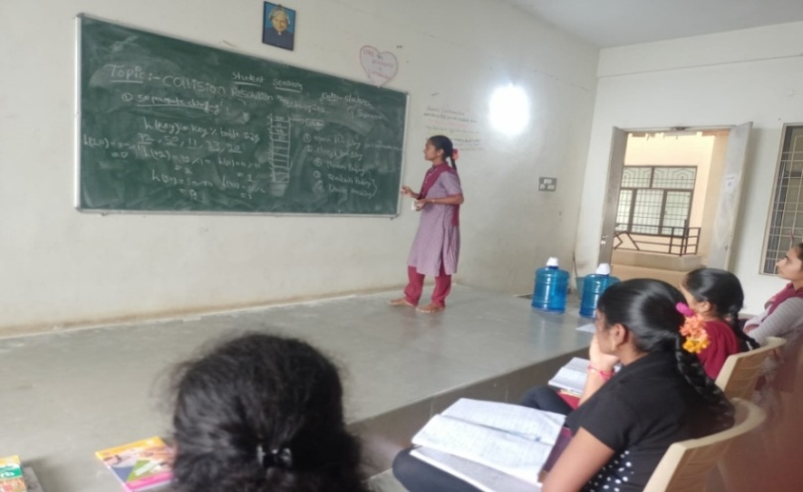

She Explained Collision Strategies of Hash in Data Structures Using C++.

- I have conduced student seminar to encourage them towards teaching and also to get rid off-stage fear.
- In this session Sameera student of II.MPCs Has participated and she given seminar on Merge sort.
- She interacted with the students very well.
- First she given introduction of the topic.
- Next she explained following points
1 .Separate Chinning
2. Linear Probing
3. Quadratic Probing
4. Double Hashing
- Student felt very happy and interesting by this session.

Name of the Activity : SEMINAR
Course : BA(CA)
Year/ Sem : I/II SEM
Lecturer Name : V BHANU PRASAD

S.No | Date | Topic | Student Details |  | No. Of Students Participated
 |  |  | H.T. No | Name
1 | 21.03.2023 | OOP Concept in C++ | 645231001 | H Hymavathi | 7
2 | 16.04.2023 | Inheritance in C++ | 645231403 | N Nageswari | 7

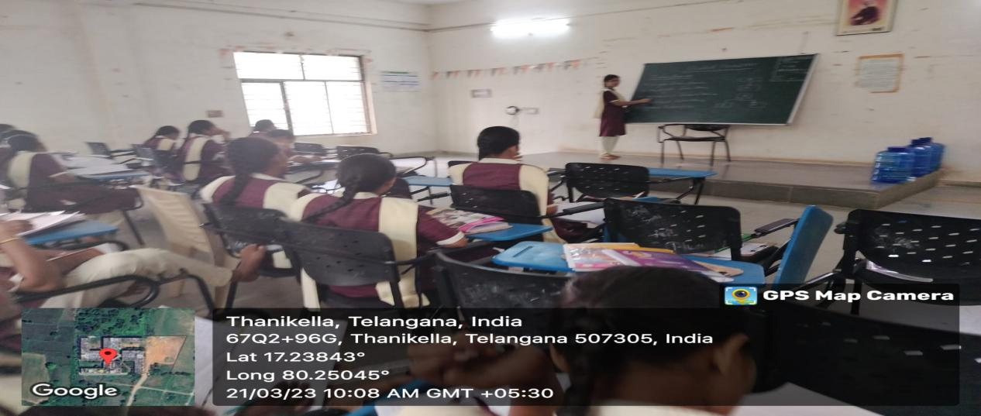

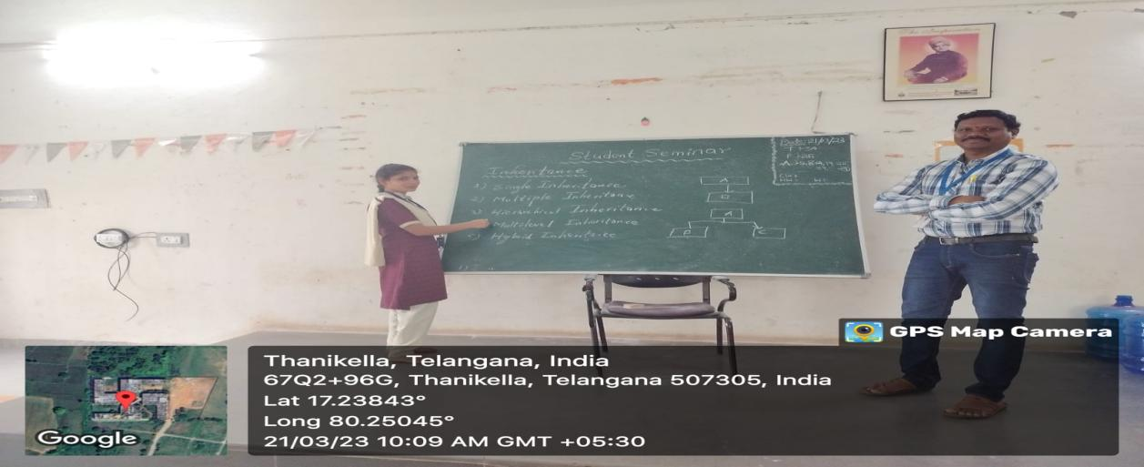

Department Activities 2022-23

CODE DEBUGGING

TOPIC : Programming in C,C++ AND JAVA
DATE :21-12-2022
PARTICIPANTS :III MPCS,MSDS

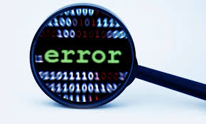

Objectives:
- The main objectives of code debugging are to identify and fix errors in code:
- Find errors: Debugging is the process of identifying where code fails.
- Fix errors: Debugging is the process of fixing mistakes in the code.
- Debugging is an important part of software development, as it can help improve code quality, reduce risks, and enhance the user experience
- Code debugging is the process of finding and fixing errors in a program's source code

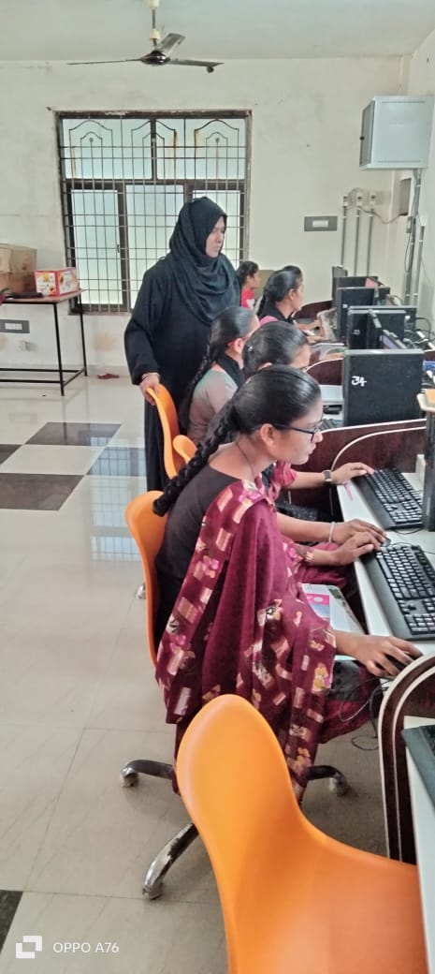
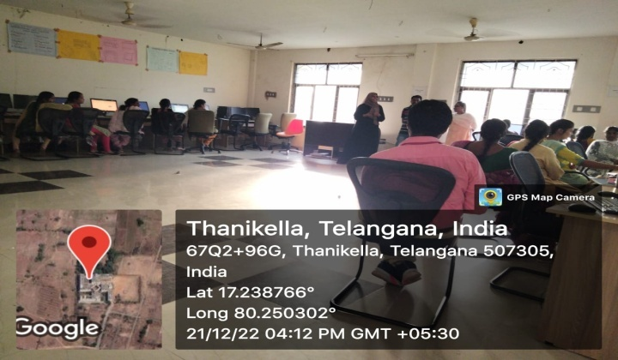

Here are some debugging techniques:
- Backtracking
A popular method for smaller programs, where developers work backwards from the point of a fatal error to identify it in the code.
- Logging
Provides detailed information about a system's status, and can trace errors back to their source.
- Breakpoints
Markers in the code that temporarily stop the program's execution so the developer can inspect the state of the program.
- Symbolic debugger
A more systematic approach to debugging, where the programmer can see values from a program dump to determine which variable it corresponds to.
The Practice:

- Students are very interested to remove errors.
- For code debugging we select the final year students
- We given the guidance to them how to read program code carefullyand try to rectify errors.
- In this session they gain the very much knowledge on the code debugging.

WORKSHOP

TOPIC : Web Development
DATE : AUG-20-2023
PARTICIPANTS : I.B.COM CA

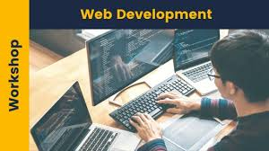
Objectives:
- The students to get actual software/website development experience in real time.
- Another important aspect of this is, students learn to work in teams and also develop leadership qualities.
- Students are gain the knowledge to develop the college website or their own website.
- For this knowledge they can get the job in IT Industry very easily
- Biggest challenge faced here is, this project internship is only for one semester which is not sufficient to complete project individually as the projects are big.
- So we allowed students to work in groups on different modules of the same project this helped in timely completion of the project.

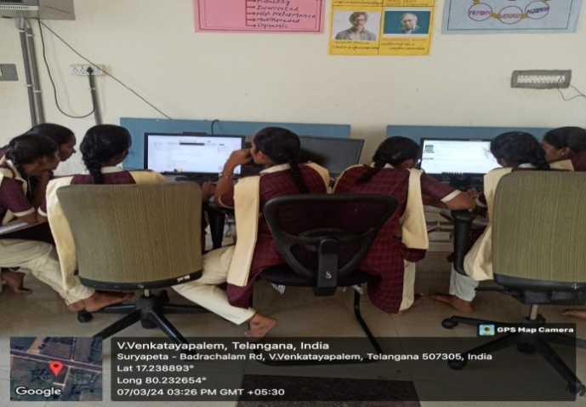
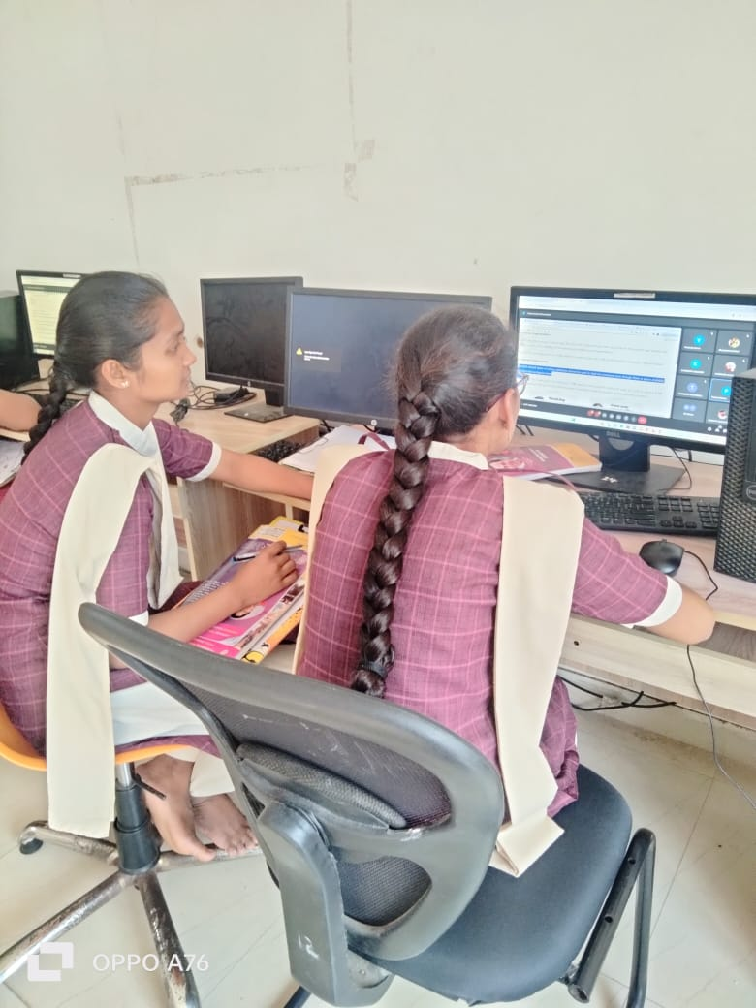

The Web Development Workshop is a great opportunity to get hands-on experience and become an expert in web development. This workshop covers the basics of HTML, CSS, JavaScript, and more, so whether you’re just getting started in web development or looking to refine your existing skills, this is the perfect place to do it. Throughout the workshop, you’ll learn the fundamentals of coding and creating a website, as well as more complex topics like animation, web design, and database management. You will also gain knowledge of the latest web technologies and industry trends. At the end of the workshop, you will have the skills necessary to create modern, dynamic websites that are both functional and aesthetically pleasing. Furthermore, you will be able to troubleshoot issues quickly and easily, so you can build robust, secure sites without wasting time on bugs.

The Practice:

- Students are very interested to develop the website.
- For website development we select the final year students
- We given the guidance to them how to create menus,sub menus and how to insert PDF files word files and images and how to create the link for the documents.
- In this session they gain the very much knowledge on the website development.

Quiz Competition

TOPIC : Programming in C.

DATE : 31.08.2023

PARTICIPANTS : IYear/ I Sem (MPCs, BA CA, BZCs)

A quiz is a form of game or mind sport in which players attempt to answer questions correctly on one or several topics. Quizzes can be used as a brief assessment in education and similar fields to measure growth in knowledge, abilities, and skills, or simply as a hobby. They can also be televised for entertainment purposes, often in a game show format.
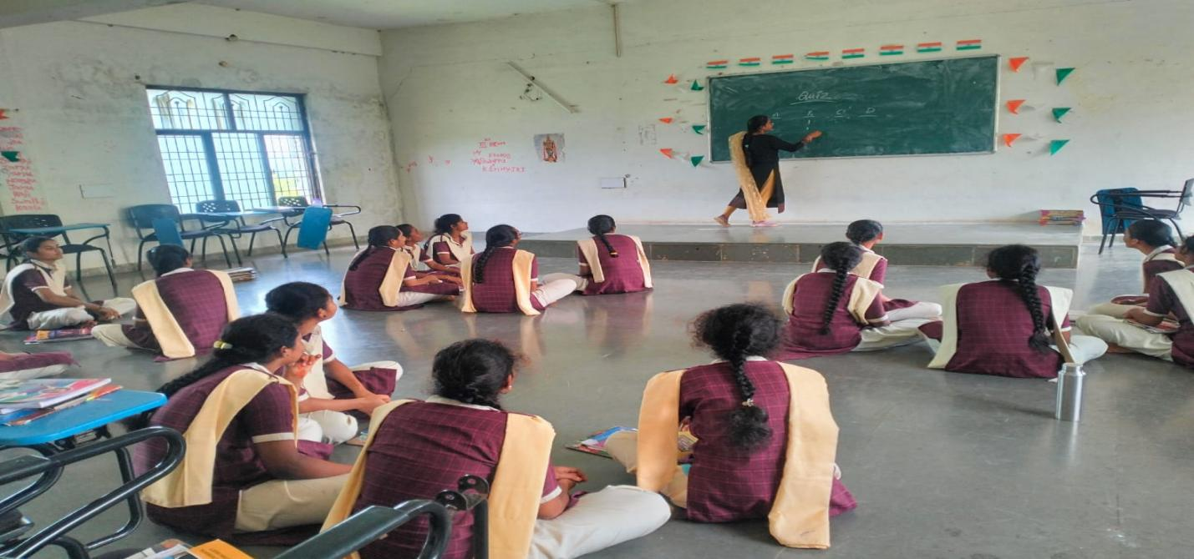

WEBINAR

TOPIC : AWARENESS ON CYBER SAFETY
DATE : 27-09-2024
PARTICIPANTS : ALL FINAL YEAR
RESOURCE PERSON : Dr.K.NIKTHA
DL In Computer Science,
MJPTBC Degree College Wargal

TGTWRDC (G), KHAMMAM College of computer science department organized a Guest Lecture on “AWARENESS ON CYBER SAFETY” on 27-09-2024.The session was organized for the students to give Awareness on Cyber Safety. Now a daywe are facing somany problem through the technology, and online crimes, mam give the awareness on how the students and girls are trapped. How they facing the problems she explained very well.

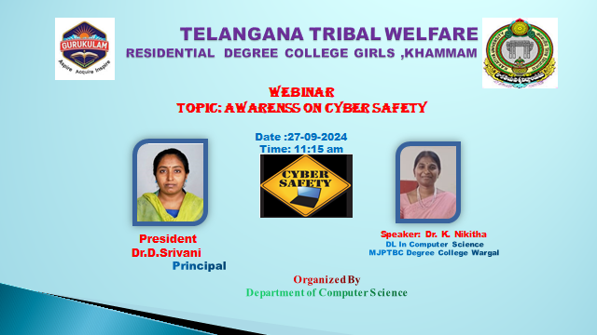

Madam covered these points also. Cyber Security Awareness is an on-going process of educating and instructing an organization’s employees about cyber security issues.
This involves being aware of the latest trends, risks, and dangers posed by a simple click on a malicious link or downloading an infected file – simple actions that, if taken lightly, can compromise privacy and data integrity.
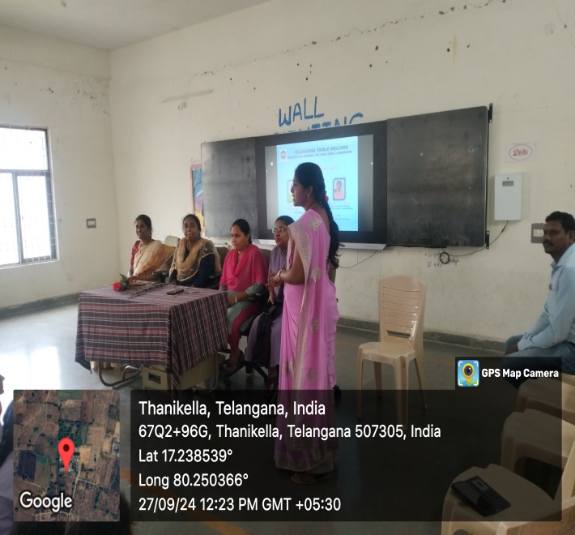
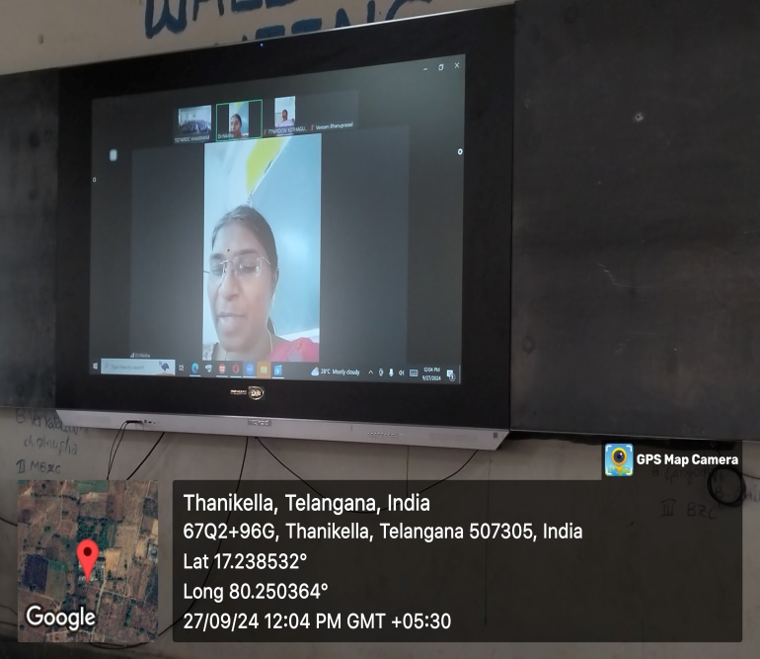
Cyber Security Awareness aims to create a behavioural profile that acts with high awareness to keep the company’s IT assets safe.

And we play some video clippings which are famous personalities are given awareness to the public as well as students and especially for the girls field and in different technologies. Students from CS department attended the session.
And our principal Dr.D.Srivani mam and, IQAC coordinator, CGC Coordinator, computer science given some instruction to the students on this topic.

The session was conducted by Dr.K.NIKITHA. This session was highly useful to the students as they got familiarized on the tools and in this session —70 students are participated.

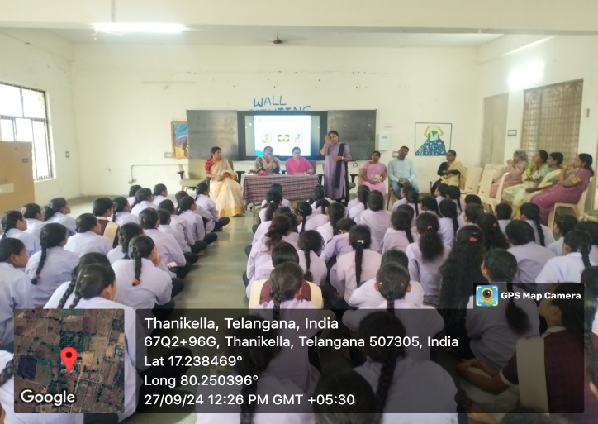
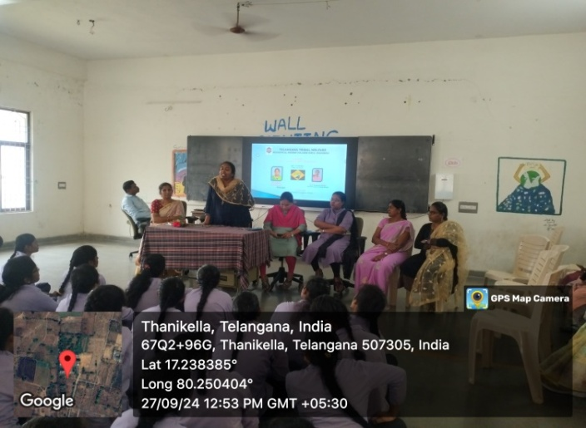

EXTENSION LECTURE 2024-2025

TOPIC : Software job opportunities and interview skills
DATE : 19-11-2024
PARTICIPANTS : ALL FINAL YEAR
RESOURCE PERSON: Dr.D.Nageswar Rao
Asst. professor,
SR & BGNR Degree College, Khammam

TTWRDC(W),KHAMMAM College of computer science department organized a Guest Lecture on “Software Job Opportunities and Interview Skills” on 19th November 2024. . The session was organized to give students brief overview of scope and career options in different computer science field and in different technologies. Sir has guided students about software job opportunities on current technologies and has given information on how to attend interview. Students from CS department attended the session.

. This session was highly useful to the students as they got familiarized on the software platform and emerging technologies and given awareness on how to face interviews. In this session —final year students are participated.

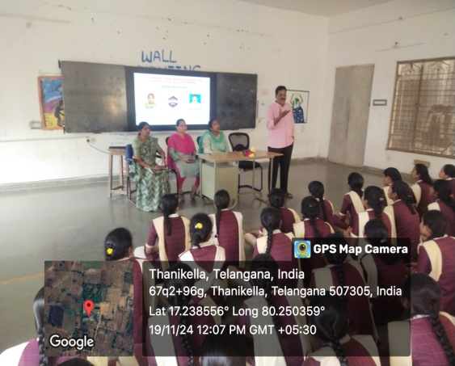

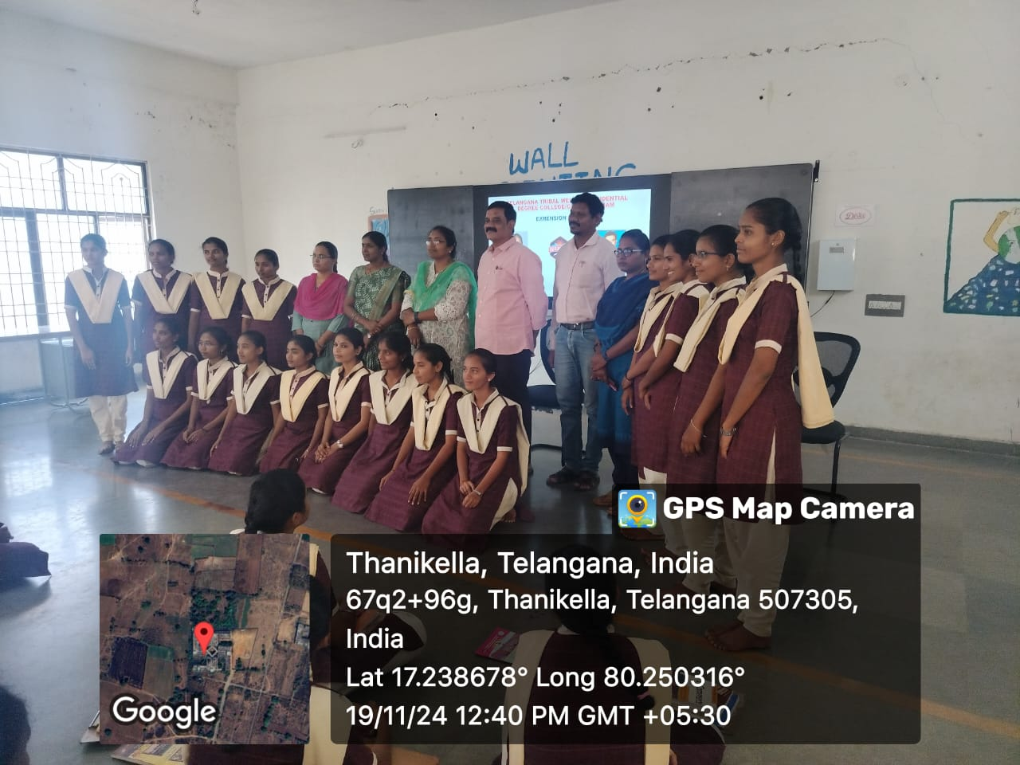

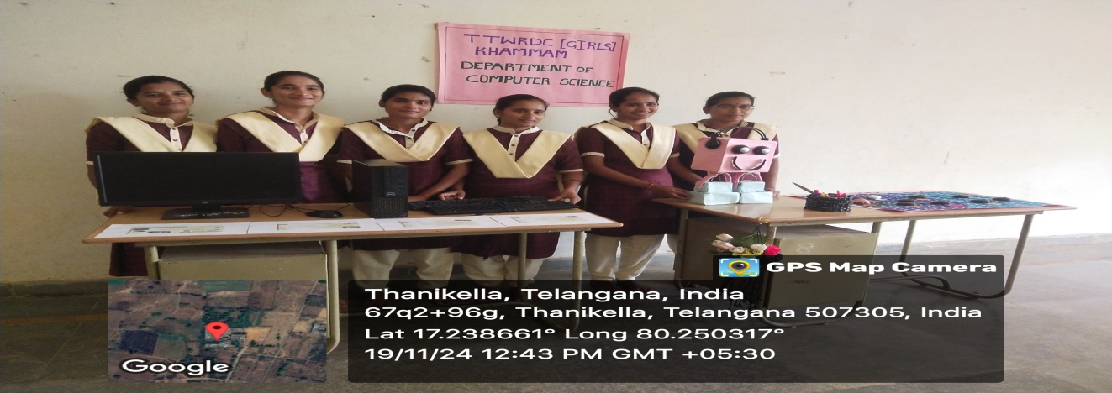

WORKSHOP

TOPIC : E-WASTE MANAGEMENT
DATE : 19-11-2024
PARTICIPANTS : ALL FINAL YEAR
RESOURCE PERSON : Dr.D.Nageswar Rao
Asst. professor,
SR & BGNR Degree College, Khammam



TTWRDC(W),KHAMMAM College of computer science department hasorganized a workshop E-Waste Management on 19th November 2024. In this session students has shown the components that are prepared from electronic waste.
E-waste is one of the fastest growing solid waste streams in the world .In 2022, an estimated 62 million tonnes of e-waste were produced globally. Only 22.3% was documented as formally collected and recycled . Lead is a common substance released into the environment when e-waste is recycled, stored or dumped using informal activities, including open burning, . Informal e-waste recycling activities may have several adverse health effects. Children and pregnant women are particularly vulnerable.LO and WHO estimate that millions of women and child labourers working in the informal recycling sector globally may be at risk of hazardous e-waste exposures .

Sir has guided students about the major problems with electronic wastage and given valuable suggestions on utilization of electronic waste. Students from CS department attended the session.

. This session was highly useful to the students as they got familiarized on the e-wastemanagement and proper utilisation of electronic resources. In this session —final year students are participated.

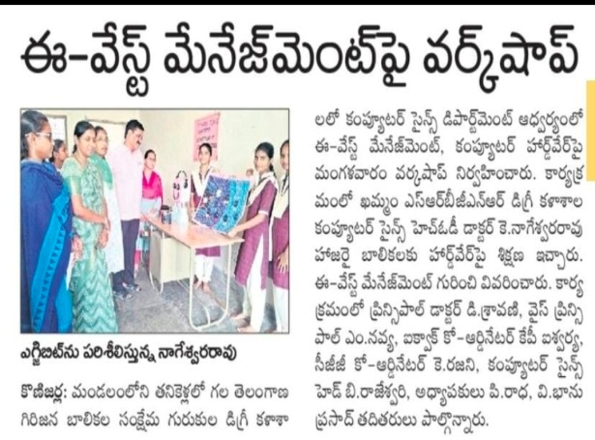
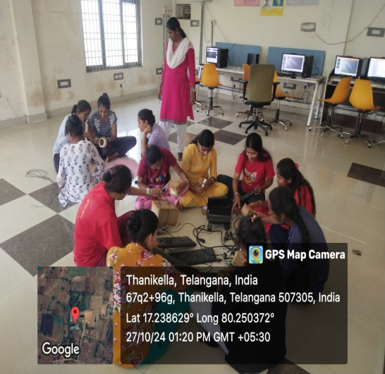
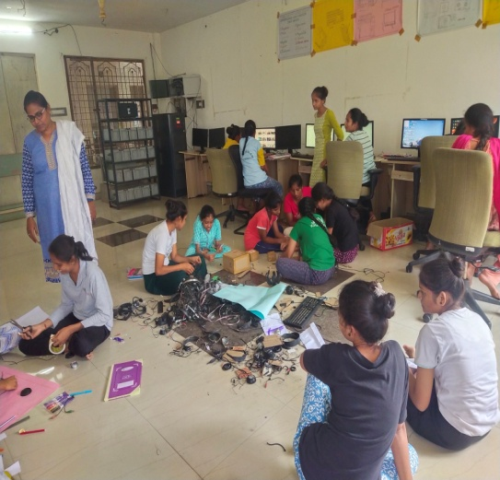

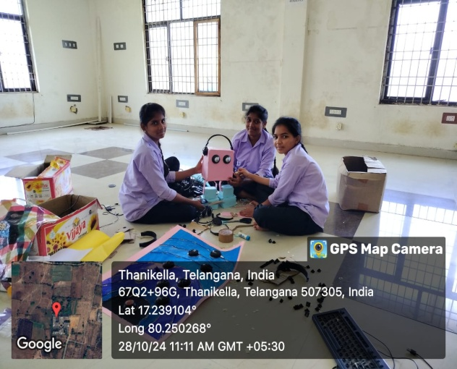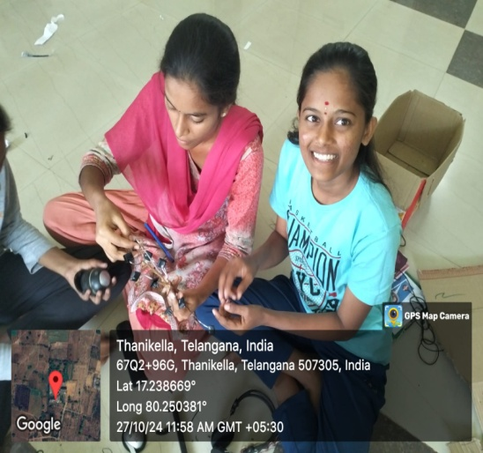

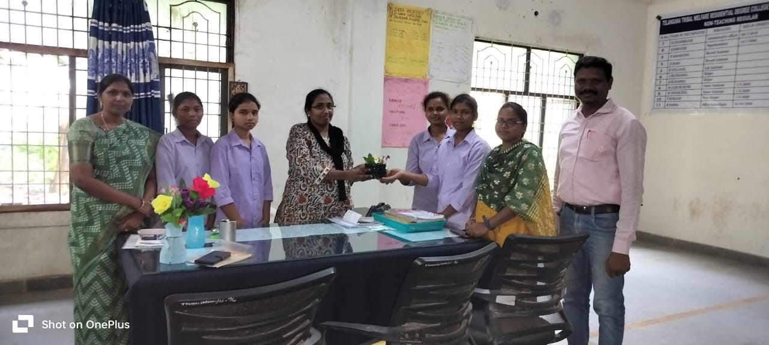

WORKSHOP

TOPIC :Digital Library and E-learning Resources
DATE :-23-11-2024
PARTICIPANTS :ALL FINAL YEAR
RESOURCE PERSON : Dr.P.Vijay Kumar
Asst. professor,
SR & BGNR Degree College,Khammam

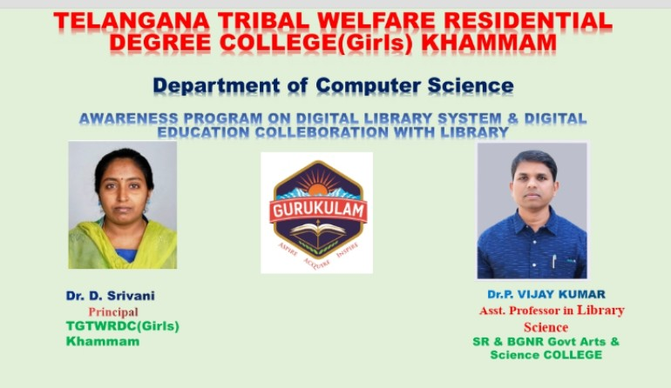

TTWRDC(W),KHAMMAM College of computer science department organized a Guest Lecture on “Digital Library and E-learning Resources” on 23rd November 2024. . The session was organized to give awareness on overview of library utilization using internet and NDLI usage as well sir has given awareness on certificate cources by Swayam, NPTEL, Swayam prabha shod ganga etc. Sir has guided students about software job opportunities on current technologies and has given information on how to attend interview. Students from CS department attended the session.

This session was highly useful to the students as they got familiarized on the tools and in this session In the end of this session sir given e-learning resources for the reference.

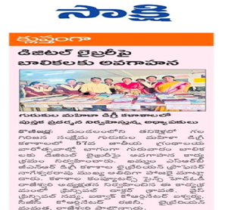
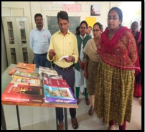

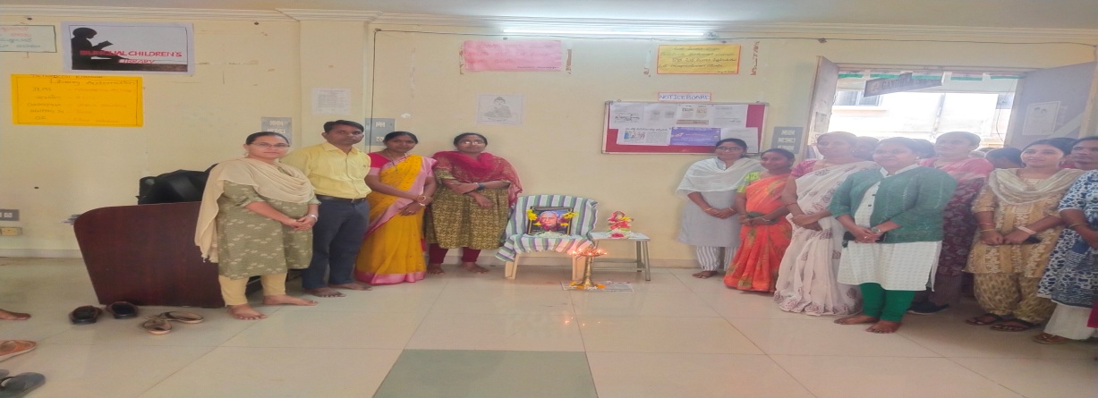

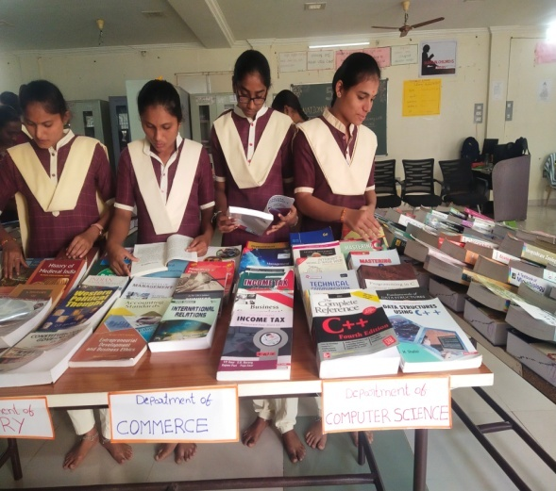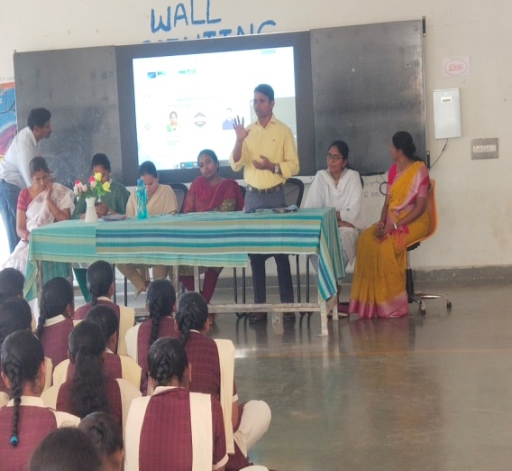

FIELD TRIP

TOPIC: MEE-SEVA APPLICATIONS
DATE:27-11-2024
LOCATION:THANIKELLA, KHAMMAM
PARTICIPANTS:III BS.C-MPCS, MSDS

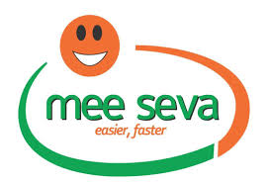

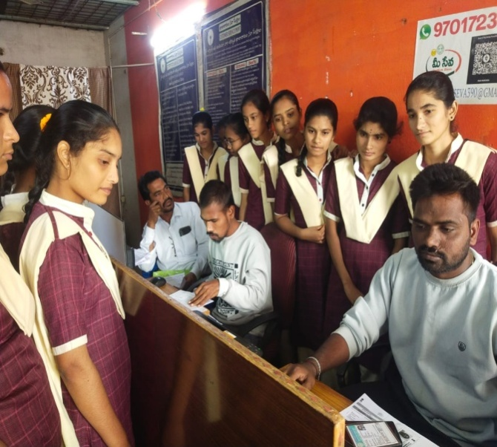
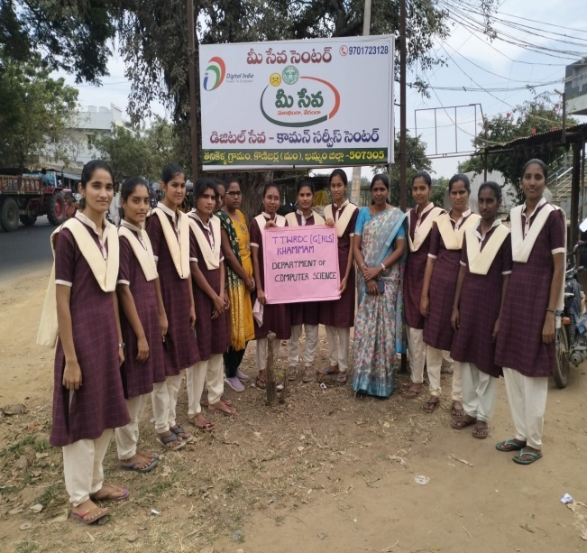

Objectives

MeeSeva is a government initiative that provides a single portal for a variety of government services to citizens and businesses
Some of the services offered by MeeSeva include:
- Applying for an age certificate
- Applying for a duplicate memorandum of marks
- Applying for a re-counting of marks
- Applying for a migration certificate
- Applying for the inclusion of a name in the electoral rolls
- Applying for a new pink ration card
- Applying for member migration in case of marriage
MeeSeva integrates existing service delivery models, such as eSeva, APOnline, and Common Service Centers (CSCs), with Mission-mode Projects like the State Data Center (SDC) and State Wide Area Networks (SWAN). The MeeSeva online portal coordinates in real-time with other government departments, such as agriculture, education, industry, and revenue.

- he objectives of the trip was to get to know the working environment of IT industries, operations, emerging technologies and skills required for the students to choose their carrier in IT Industry.
- Field trips make learning more engaging, memorable, and relevant. Furthermore, they promote critical thinking, enhance observational skills, and nurture a sense of curiosity and wonder.
- Outdoor education emphasizes holistic development. Activities such as team-building exercises, problem-solving challenges, and nature walks nurture not just cognitive skills but also emotional, social, and physical well-being. Students learn resilience, adaptability, and interpersonal skills in real-time, real-world scenarios.
BEST PRACTICE
- Main aim of Field Trip is to provide an exposure to students about practical working environment.
- They also provide students a good opportunity to gain full awareness about industrial practices. Through Field Trip students get awareness about new technologies.
FIELD TRIP

TOPIC: Andhra Pradesh Grameena Vikas Bank
DATE:27-11-2024
LOCATION:THANIKELLA, KHAMMAM
PARTICIPANTS:III BS.C-MPCS, MSDS
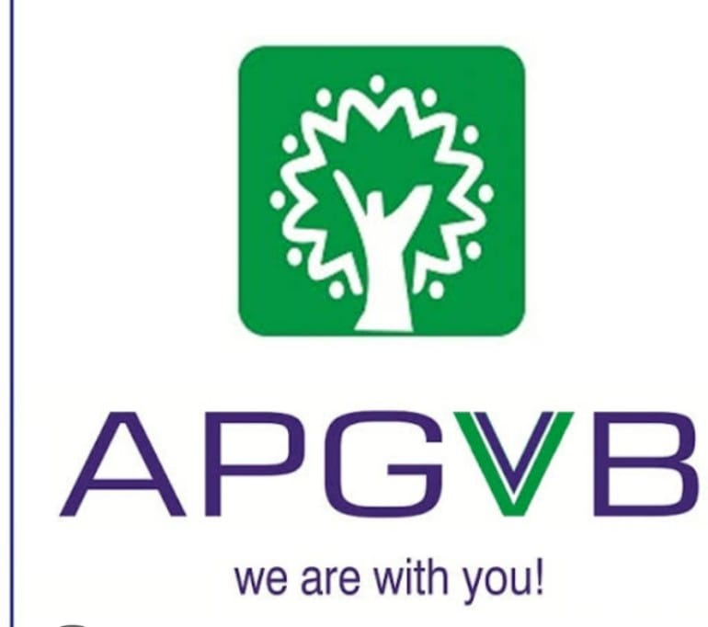

The full form of APGVB is Andhra Pradesh Grameena Vikas Bank. APGVB is a rural Indian regional bank located in Warangal, India. As per the Regional Rural Banks Act of 1976, it was founded as a Regional Rural Bank in 2006. Through the amalgamation of the five following banks, funded by the SBI, on 31 March 2006, to engage more actively, with coordination, in the boost and growth of the rural & rural non-agricultural sectors, with a focus on the urban, the rural poor, the rural ISB & rural crafts.
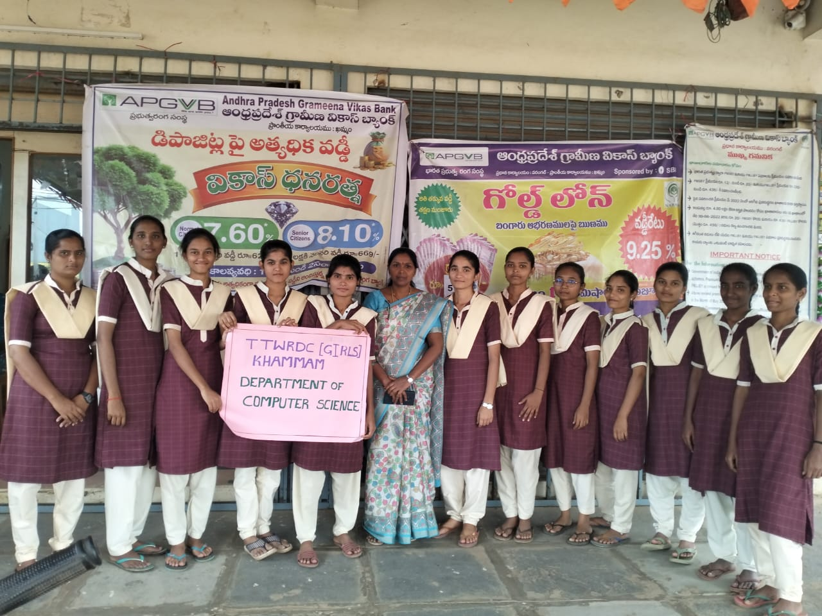
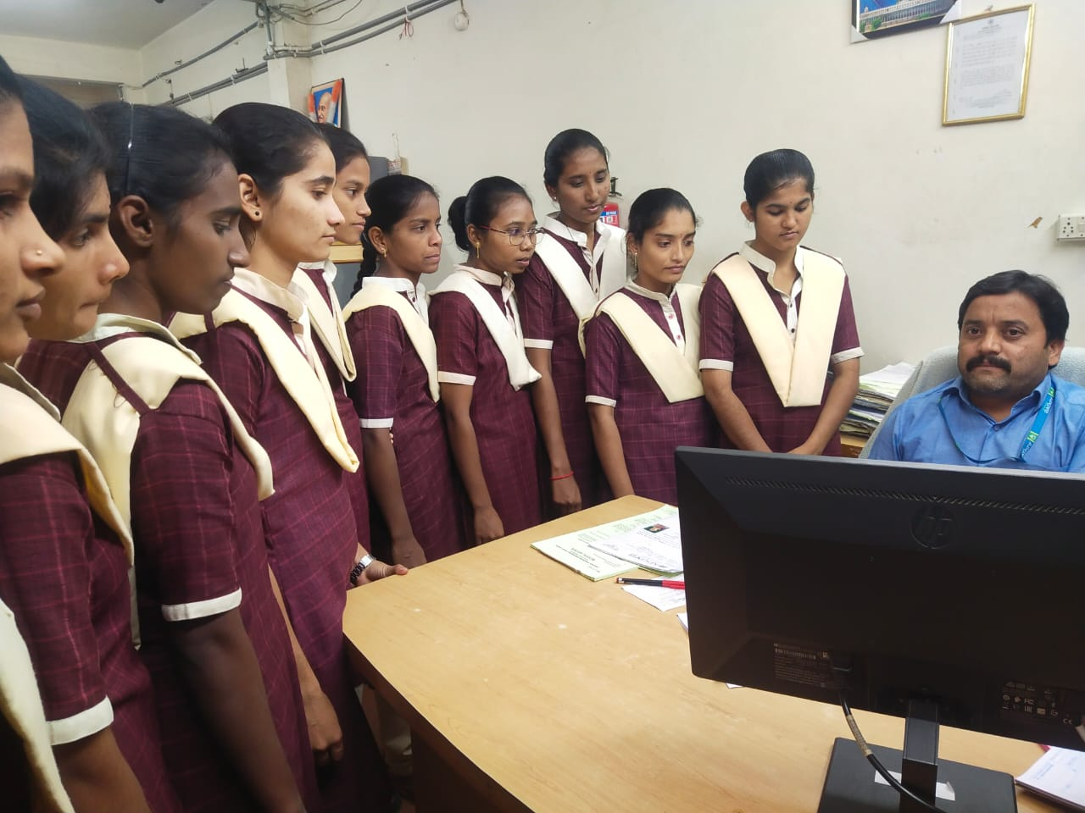
Objectives
- he objectives of the trip was to get to know the working environment of IT industries, operations, emerging technologies and skills required for the students to choose their carrier in IT Industry.
- Field trips make learning more engaging, memorable, and relevant. Furthermore, they promote critical thinking, enhance observational skills, and nurture a sense of curiosity and wonder.
- Outdoor education emphasizes holistic development. Activities such as team-building exercises, problem-solving challenges, and nature walks nurture not just cognitive skills but also emotional, social, and physical well-being. Students learn resilience, adaptability, and interpersonal skills in real-time, real-world scenarios.
BEST PRACTICE
- Main aim of Field Trip is to provide an exposure to students about practical working environment.
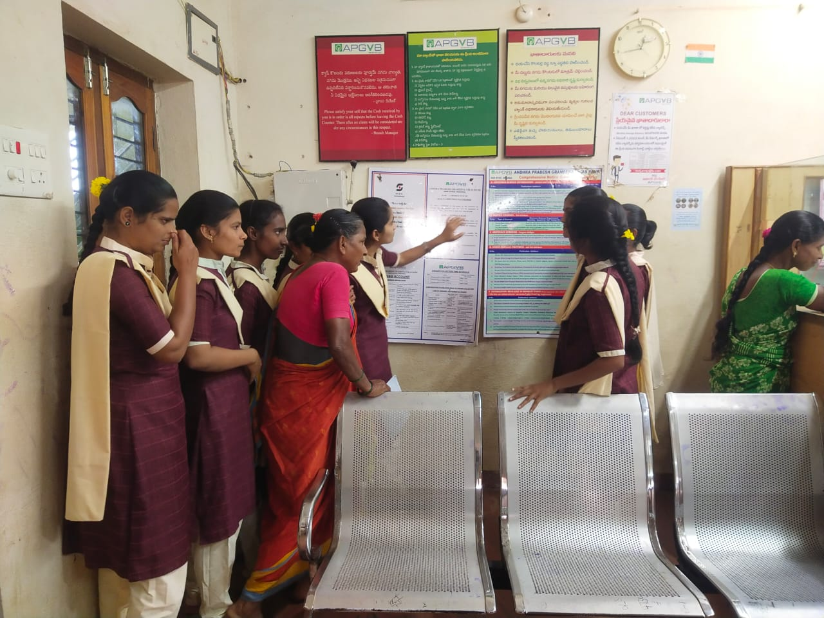
- They also provide students a good opportunity to gain full awareness about industrial practices. Through Field Trip students get awareness about new technologies.

SEMINAR

S.NO | DATE | NATURE OF ACTIVITY | TOPIC | NAME OF THE LECTURE INVOLVED | DETAILS OF STUDENT NAME ,H.T.NO | NO OF STUDENTS PARTICIPATED
1 | 11.09.2024 | SEMINAR | BLOCK DIAGRAM OF COMPUTER | V BHANU PRASAD | G. MUNNI | 11
2 | 13.09.2024 | SEMINAR | BUSINESS MODELS IN ECOMMERCE | P.RADHA | B.SEETH  MAHALAXMI -645232210 | 24
3 | 13.09.2024 | SEMINAR | BUSINESS MODELS IN ECOMMERCE | P.RADHA | D.ANU  645232216 | 24
4 | 20.09.2024 | SEMINAR | SQL LANGUAGES | B.RAJESWARI | ANUSHA | 30
5 | 20.09.2024 | SEMINAR | JOIN  OPERATIONS | B.RAJESWARI | I. SREJA  645241003 | 12
6 | 20.09.2024 | SEMINAR | TCP/IP PROTOCOL | P.RADHA | E.NAVYA SRI  645232219 | 26
7 | 22.10.2024 | SEMINAR | INPUT OUTPUT DEVICE | B.RAJESWARI | D.TULASI | 32
8 | 22.10.2024 | SEMINAR | PACKAGES IN JAVA | V BHANU PRASAD | BANITH INDU  645234105 | 18
9 | 28.10.2024 | SEMINAR | SQL LANGUAGES | B.RAJESWARI | K.NAVYA  645241004 | 12
10 | 29.10.2024 | SEMINAR | NUMPY IN PYTHON | B.RAJESWARI | T.NAGA KAVYA SRI  645244307 | 8
11 | 11.05.2024 | SEMINAR | THREAD LIFE CYCLE | V BHANU PRASAD | N NAGESWARI  645231403 | 7
12 | 28.11.2024 | SEMINAR | ARRAYS IN C | V BHANU PRASAD | E PRASHANTHI

TOPIC: SQL LANGUAGES
DATE:9/20/2024
PARTICIPANTS:II BA
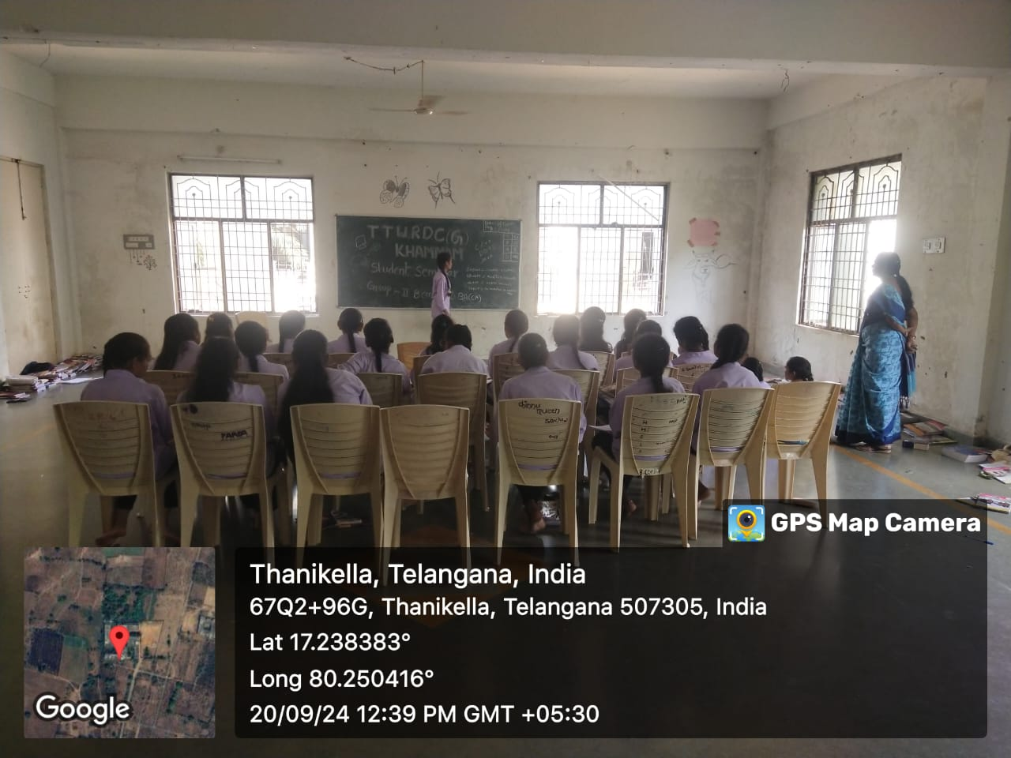
TOPIC-JOIN OPERATIONS
I have conduced student seminar to encourage them towards teaching and also to get rid off-stage fear.
- In this session K.SRIJA student of II.BA CA has participated. She has given seminar on JOIN OPERATIONS
- She interacted with the students very well
- First she given introduction of the topic.
- Next she explained following points
1 .JOIN DEFINITION
2. JOIN TYPES
3. COMMANDS
Student felt very happy and interesting by this session

STUDENT NAME: ANUSHA II BCOM CA

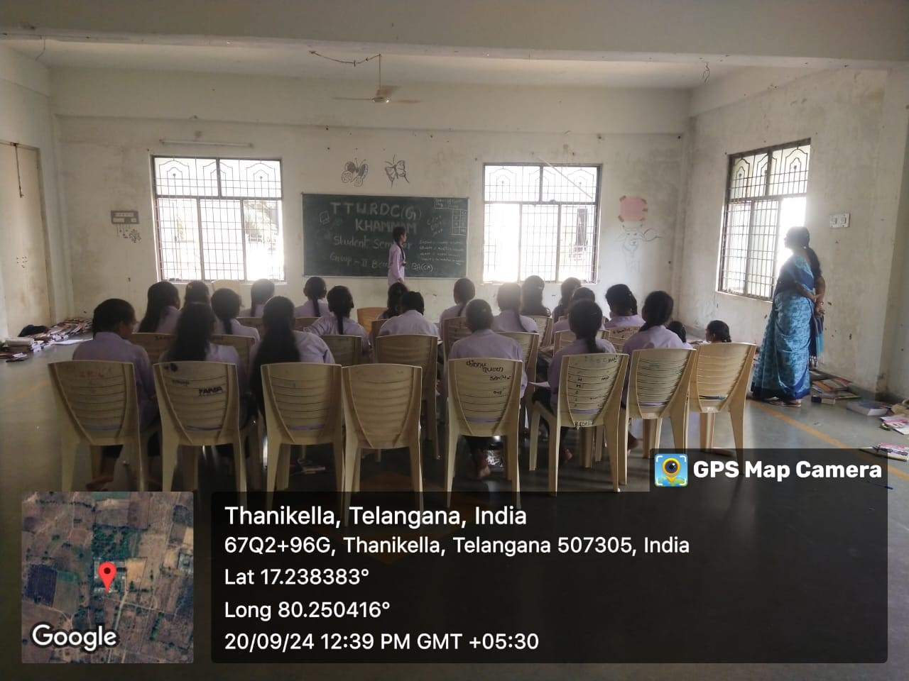

TOPIC: SQL LANGUAGES
DATE:9/20/2024
PARTICIPANTS:II BA

TOPIC-DML COMMANDS
I have conduced student seminar to encourage them towards teaching and also to get rid off-stage fear.
- In this session ANUSHA student of II.BCOM CA has participated. She has given seminar on DML COMMANDS
- She interacted with the students very well
- First she given introduction of the topic.
- Next she explained following points
1 .INSERT COMMAND
2. UPDATE COMMAND
3. DELETE COMMAND
Student felt very happy and interesting by this session

STUDENT NAME –D.TULASI I BCOM CA

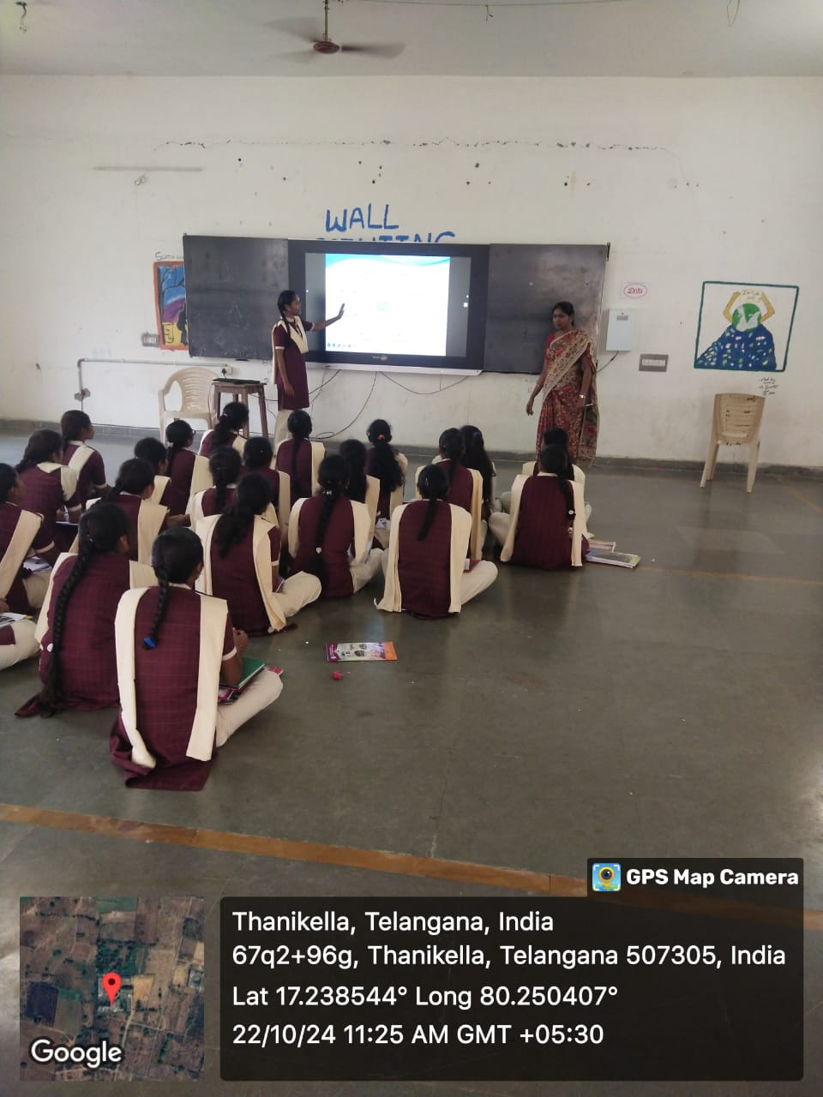

TOPIC: SQL LANGUAGES
DATE:9/20/2024
PARTICIPANTS:II BA

TOPIC-INPUT OUTPUT DEVICE
I have conduced student seminar to encourage them towards teaching and also to get rid off-stage fear.
In this session D.TULASI student of I BCOM CA has participated. She has given seminar on - INPUT OUTPUT DEVICE

- She interacted with the students very well
- First she given introduction of the topic.
- Next she explained following points
1 INPUT DEVICES LIKE KEYBOARD, MOUSE, etc.
2.OUTPUT DEVICES LIKE MONITOR, PRINTER etc.

Student felt very happy and interesting by this session

STUDENT NAME: K.NAVYA II BA (CA)

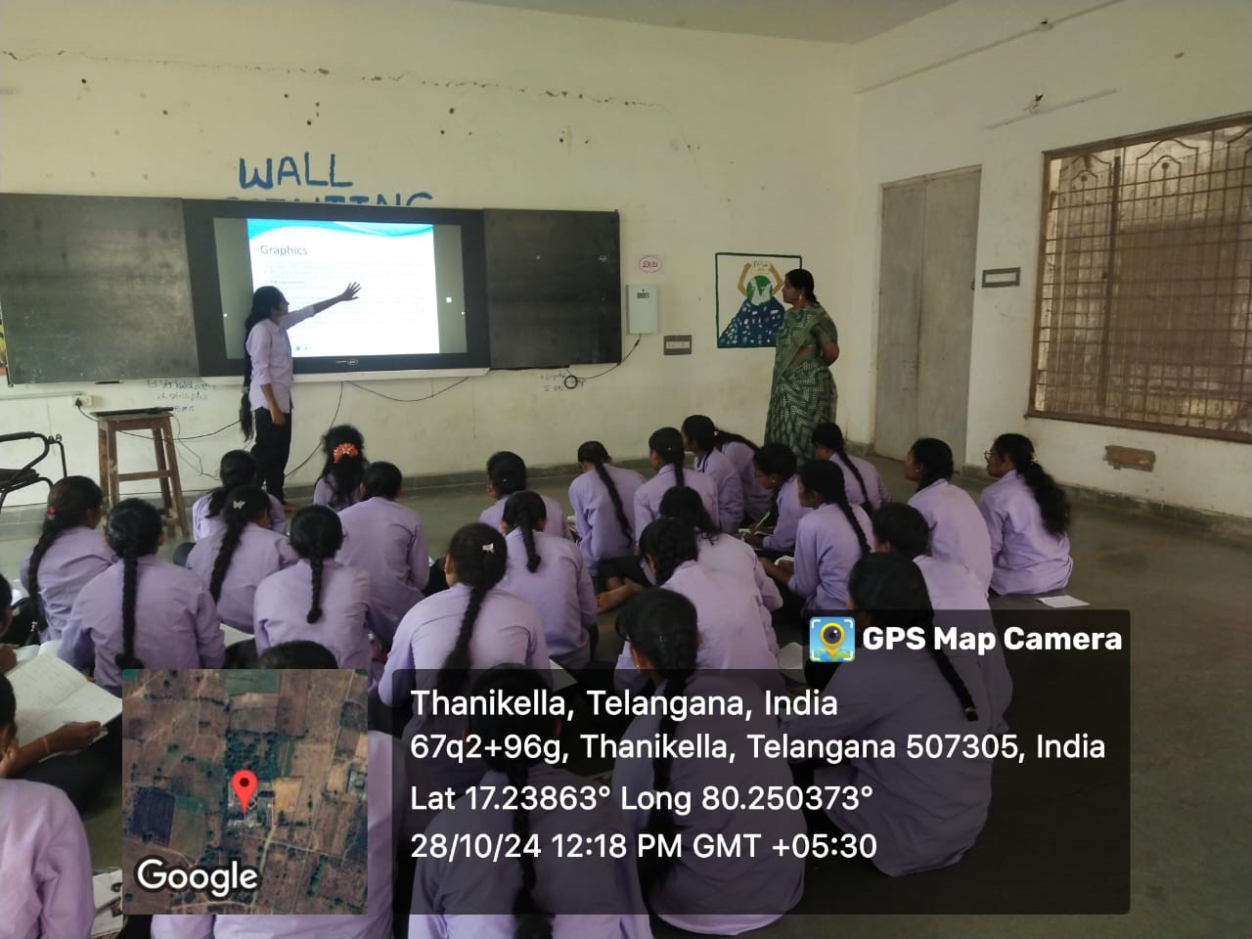

TOPIC: SQL LANGUAGES
DATE:9/20/2024
PARTICIPANTS:II BA

TOPIC- SQL LANGUAGES
DML COMMANDS
I have conduced student seminar to encourage them towards teaching and also to get rid off-stage fear.
- In this session student of K NAVYA II.BA CA has participated. She has given seminar on DML COMMANDS
- She interacted with the students very well
- First she given introduction of the topic.
- Next she explained following points
1 .INSERT COMMAND
2. UPDATE COMMAND
3. DELETE COMMAND
Student felt very happy and interesting by this session

STUDENT NAME –T.NAGA KAVYA SRI II.MSDS

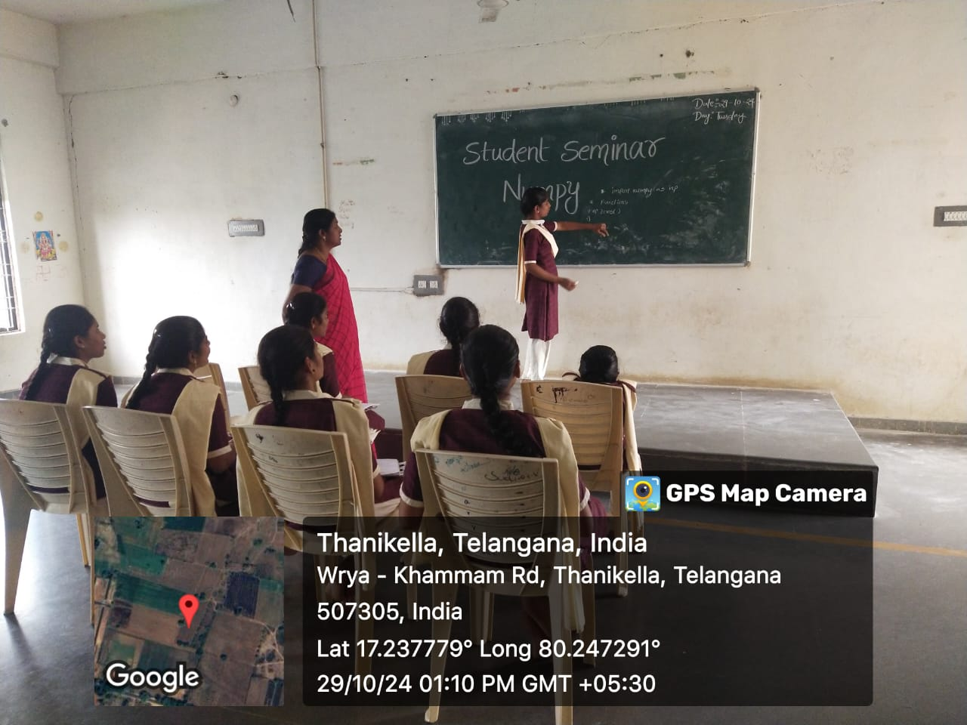

TOPIC: SQL LANGUAGES
DATE:9/20/2024
PARTICIPANTS:II BA

TOPIC-NUMPY IN ENGINEERING WITH PYTHON
I have conduced student seminar to encourage them towards teaching and also to get rid off-stage fear.
- In this session T.NAGA KAVYA SRI student of II.MSDS has participated. She has given seminar on NUMPY
- She interacted with the students very well
- First she given introduction of the topic.
- Next she explained following points
1 NUMPY COMMANDS

2.FUNCTIONS AND METHODS
3. SIMPLE CODE
Student felt very happy and interesting by this session

STUDENT SEMINAR

S.NO | DATE | NATURE OF ACTIVITY | TOPIC | NAME OF THE LECTURE INVOLVED | DETAILS OF STUDENT NAME ,H.T.NO | NO OF STUDENTS PARTICIPATED
1 | 13-09-2024 | SEMINAR | BUSINESS MODELS IN ECOMMERCE | P.RADHA | B.SEETH  MAHALAXMI -645232210 | 24
2 | 13-09-2024 | SEMINAR | BUSINESS MODELS IN ECOMMERCE | P.RADHA | D.ANU  645232216 | 24
3 | 20-09-2024 | SEMINAR | TCP/IP PROTOCOL | P.RADHA | E.NAVYA SRI  645232219 | 26

Name of the Lecturer involved: P.RADHA
S.No | Date | Nature of Activity | Topic | Details of Student (Name, Hall Ticket No, etc. ) | No. of students participated
1 | 13-SEP-2024 | SEMINAR | BUSINESS MODELS IN ECOMMERCE | B.SEETH  MAHALAXMI -645232210 | 24
Seminar Topic: -BUSINESS MODELS IN ECOMMERCE

Name of the Student: B.SEETHMAHALAXMI -
Contents Covered by Student:
I have conduced student seminar to encourage them towards teaching and also to get rid off-stage fear.
In this session students B.SEETHMAHALAXMI -645232210 of III.B.COM (CA) Has participated and she given seminar on BUSINESS MODELS IN ECOMMERCE
She interacted with the students very well .First she given introduction of the topic. Next she explained following points types of BUSINESS MODELS B-B,B-C,C-C etc., Student felt very happy and interesting by this session.
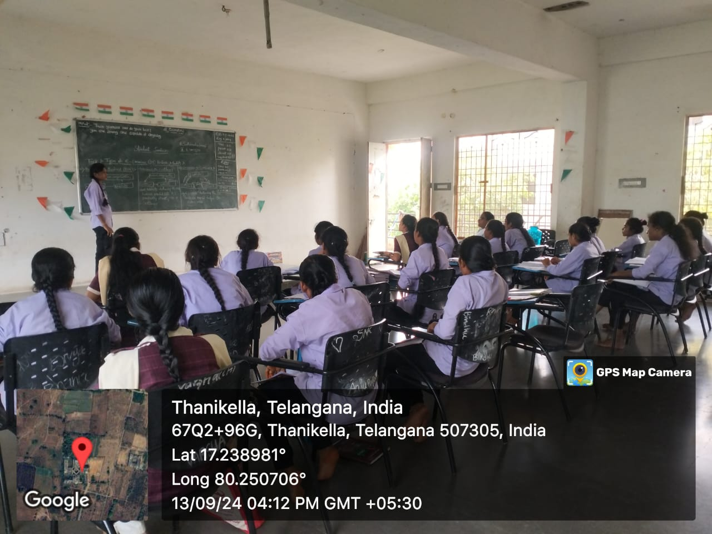

Name of the Lecturer involved: P.RADHA
S.No | Date | Nature of Activity | Topic | Details of Student (Name, Hall Ticket No, etc. ) | No. of students participated
1 | 13-09-2024 | SEMINAR | BUSINESS MODELS IN ECOMMERCE | D.ANU  645232216 | 24
Seminar Topic: - BUSINESS MODELS IN ECOMMERCE

Name of the Student:D.ANU

Contents Covered by Student:
I have conduced student seminar to encourage them towards teaching and also to get rid off-stage fear.
In this session students D.ANU 645232216 of III.B.COM CA Has participated and she given seminar on BUSINESS MODELS IN ECOMMERCE
She interacted with the students very well. First she gave introduction of the topic. Next she explained following points types of BUSINESS MODELS B-B,B-C,C-C etc., Student felt very happy and interesting by this session.
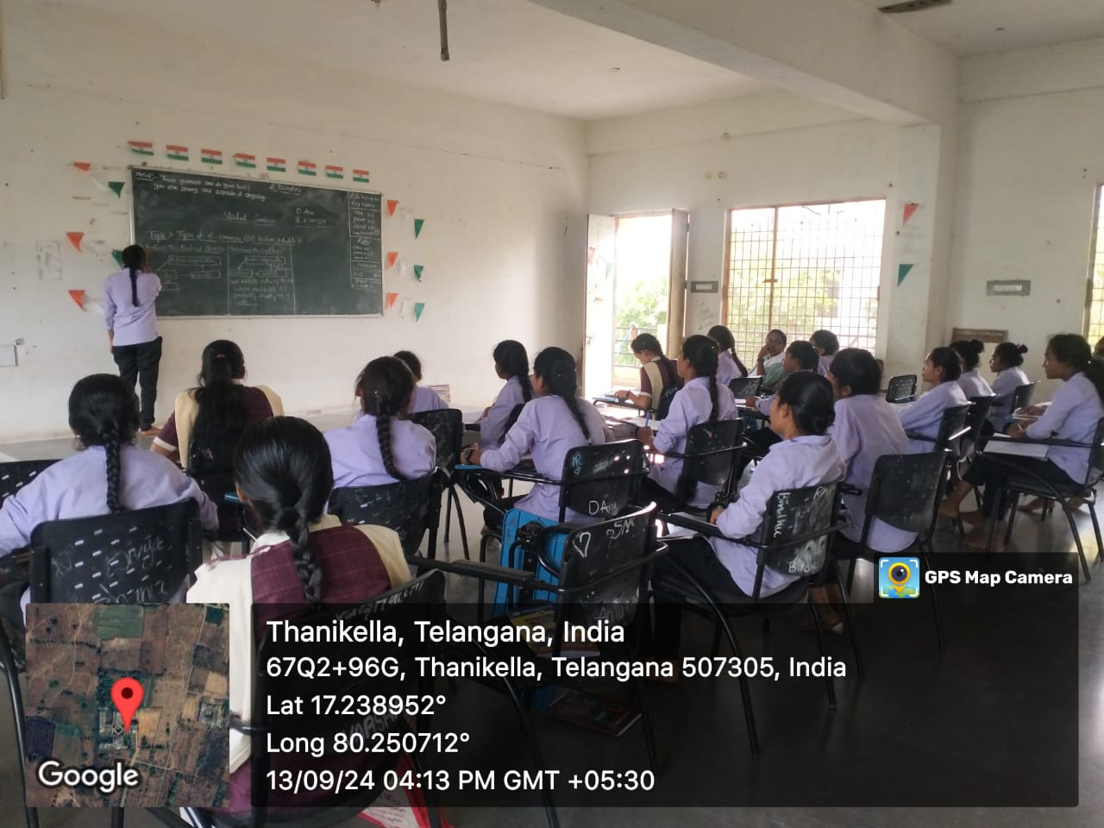

Name of the Lecturer involved: P.RADHA
S.No | Date | Nature of Activity | Topic | Details of Student (Name, Hall Ticket No, etc. ) | No. of students participated
1 | 20-09-2024 | SEMINAR | TCP/IP PROTOCOL | E.NAVYA SRI  645232219 | 26
Seminar Topic: - TCP/IP PROTOCOL
Name of the Student: E.NAVYA SRI
Contents Covered by Student:
I have conduced student seminar to encourage them towards teaching and also to get rid off-stage fear.
In this session students E.NAVYA SRI 645232219 of III.B.COM (CA) has participated and she given seminar on TCP/IP PROTOCOL
She interacted with the students very well. First she gave introduction of the topic. Next she explained following points. Use of protocol and layers of protocol. The TCP/IP model was developed prior to the OSI model. This protocol consists of five layers: the application layer, transaction layer, network layer, data link layer and physical layer etc., Student felt very happy and interesting by this session.
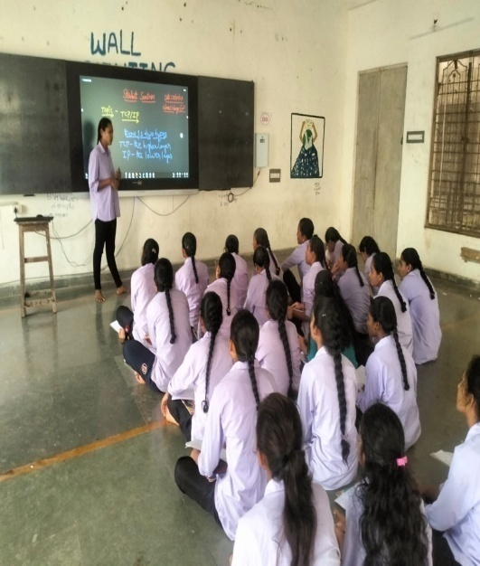
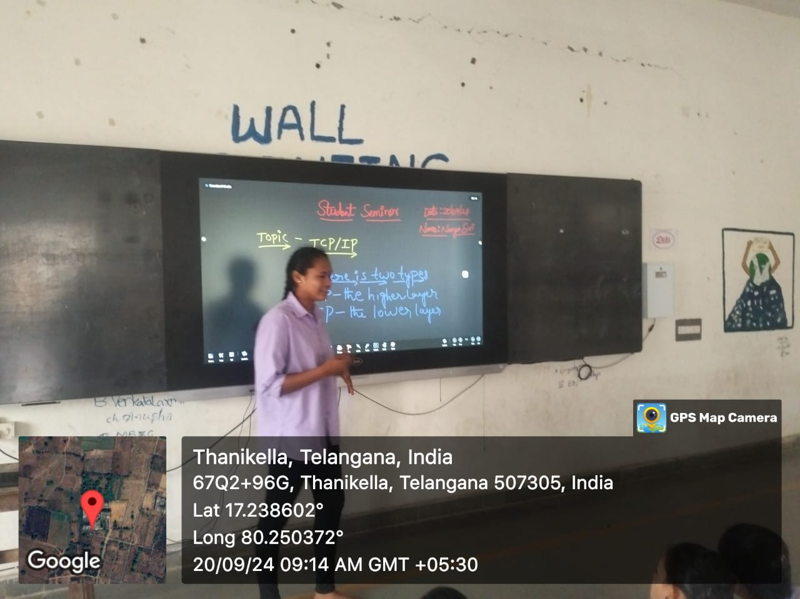

Name of the Lecturer involved: P.RADHA
S.No | Date | Nature of Activity | Topic | Details of Student (Name, Hall Ticket No, etc. ) | No. of students participated
1 | 20-DEC-2021 | SEMINAR | SQL | A.SWAPNA 645202201 | 30

Seminar Topic: -SQL

Name of the Student: A.SWAPNA
Contents Covered by Student:
I have conduced student seminar to encourage them towards teaching and also to get rid off-stage fear.
- In this session students A.SWAPNA 645202201 II.B.COM CA Has participated and she given seminar on SQL ITRODUCTION
- She interacted with the students very well
- First she given introduction of the topic.
- Next she explained following points USES OF SQL COMMANDS IN SQL etc.,
- Student felt very happy and interesting by this session.
